**StaySafeMedical.com**

**Hospital Management System**



**Prof. Charles Li**

**CST3504**

**Team Members: Chowdhury Hashmee & Mahim Pritom**

**Table of Content**

**Executive Summary………………………………………………………………………………3**

**Objectives………………………………………………………………………………………...3**

**Team Members…………………………………………………………………………………...4**

**Targeted Technical Architecture………………………………………………………………...5**

**Targeted Methodology & Plan…………………………………………………………………..6**

**Business Requirements………………………………………………………………………..7-9**

**EER Conceptual Model…………………………………………………………………………10**

**Normalized Logical Model……………………………………………………………………..11**

**Data Dictionary……………………………………………………………………………..12-19**

**Physical Model Schema Diagram……………………………………………………………...20**

**Development & Implementation Phase-Script File……………………………………….21-29**

**Testing & Validating Via Queries………………………………………………………….30-41**

* **User Interface…………………………………………………………………………...42**

**Conclusion………………………………………………………………………………………43**

**Executive Summary**

StaySafeMedical.com is a complete hospital management system. It will help the user from different location throughout the country. To do this job, this system will have different types of database systems based on the requirements and performance. Project management system will be applied to complete each task, and everything will be documented accordingly.

**Objectives**

The main goals to design & implement a database application for a Hospital Management System Application named “StaySafeMedical.com”. The application is to automate the managing of patients and hospital personnel activities etc. This system allows hospital employees to conveniently manage hospital patient activities such as assigning physicians, medical care, registration etc.

The application uses **Three-Tiered Web-based Client/Server** – for customers, physicians, nurses and other medical professionals to manage the day activities in the hospital online via a browser.

**Two-Tiered Windows-Client Client/Server** – Front line workers such as emergency room administrators, nurses, registration clerks etc.

**Database Tier** – both the Three-tiered Web and Two-tiered Windows client/server will SHARE the same Database tier.

It will also support dozens of major cities around the world. In addition, provide a great user experience in Hospital Reservations.

There are multiple requirements in order to complete the whole process. The Project must need planning analyzing, designing and implementing phases to successfully complete the projects.

**Team Members**

For this project, we have a group of two members including me, Mahim Pritom, and Chowdhury Hashmee.

**Mahim Pritom**

Hi, I am Mahim Pritom. I am a senior year student majoring in Computer Systems at New York City College of Technology. For this project, my focus will be on designing, implementation, and testing. For designing, I will focus on ER diagram, logical and relational model. In terms of implementation, I will be working with SQL queries, generated DDL, creating tables, inserting data and build data dictionary. Finally, for testing, I will focus on update and delete statements to test our database. Let’s get it.

**Chowdhury Hashmee**

Hey I am Chowdhury Hashmee. I am doing my bachelor’s in computer systems at New York City College of Technology. For this project, my role will be project planning, analysis our business requirements and make presentation of our project. I will be partnering with Mahim Pritom in this project to accomplish our objectives. For the project planning and analysis, I will be assisting Mahim for planning phase as we progress and what needs to be implemented accordingly. I am looking forward to completing this project.

**Targeted Technical Architecture**

The system is a combination of 1) Three-Tiered Web Database Application with a web-based browser front-end for the users that want to make reservations via the internet or travel agency employees that require a browser-based application. In addition, we have an additional architecture: 2) Two-Tiered Windows Database Application, with a custom client front-end to for the application used by check-in desk at the airports and other airline users that require fast performance. Note that both these architecture (Web & Custom client) share the same DBMS back-end data store. Below is the full architecture we are targeting:

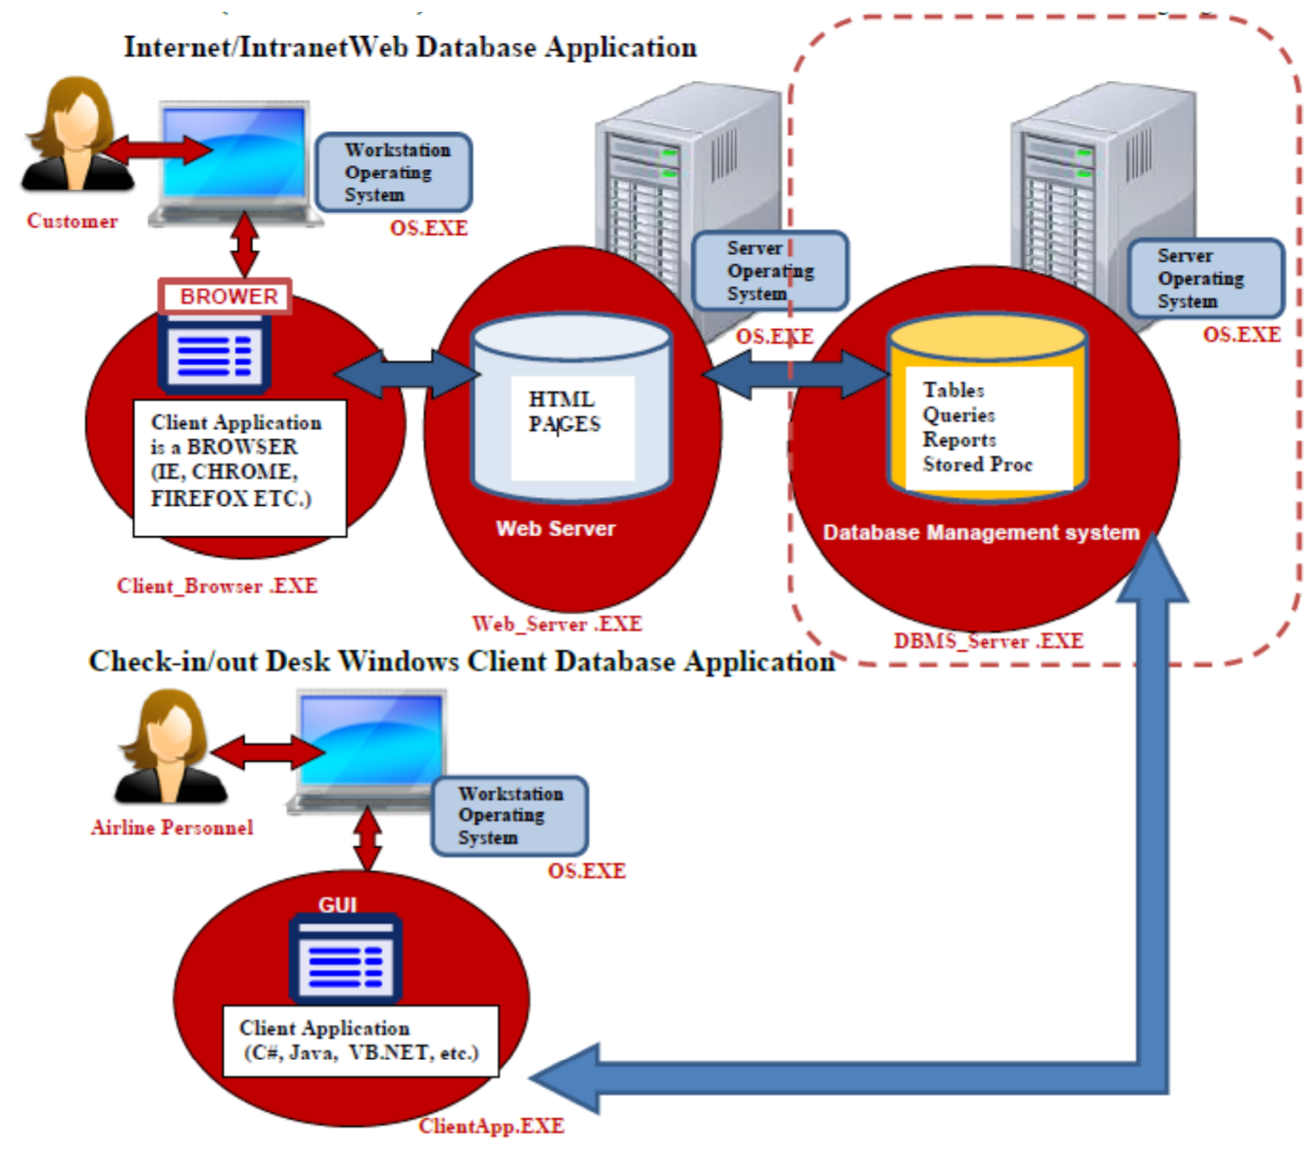This project will focus only on the DBMS or backend design and implementation using a DBMS.

**Targeted Methodology & Plan**

We will use our project management database lifecycle methodology for the project by implementing the Planning Phase, Analysis Phase, and part of the Design Phase for the Hospital Reservations System.

Below are the 5 PHASES & their main deliverables:

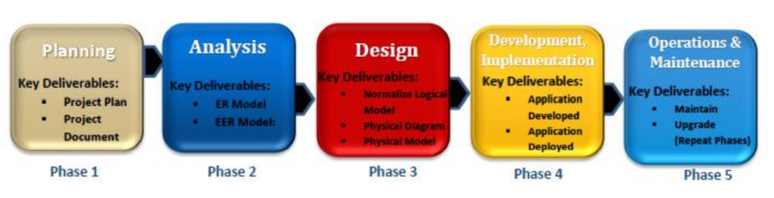

High-level description of this methodology:

* **Planning:** Plan the entire project from a high-level. Gather requirements from business. Decide on methodology etc.
* **Analysis:** Analyze the business or organization in order to determine requirements for developing database. Deep analysis of requirements.
* **Design:** Organize all the requirements and produce a detailed specification of all data, forms, reports, displays, and processing or business rules. This includes purchase of all hardware, software etc.
* **Implementation:** Create the database, tables, view, stored procedures etc. Create Front-End Client programs. Test and install system, train users and document the installation and Standard Operation Procedures (SOP).
* **Maintenance/Administration:** Monitor, backup & repair the system. Periodically audit system to ensure it continues to meet requirements. Have a disaster/recovery system in place. (Excluded from our project)

**Business Requirements**

Hospital Management System Business & Technical Detailed Requirements below:

* A Business Analyst was hired by Mr. Chowdhury to compile the list of requirements based on the results of interviews and conversations with the various business stakeholders. Below are the requirements captured by the Business Analyst:
* This “StaySafeMedical.com” Hospital Management System is designed to allow hospital physicians, nurses and employees to manage outpatients and resident patient hospital activities.
* The application is to support our hospitals in major cities in the US and around the world. Both the client application and the website need to capture the following information:
* As a large service organization, StaySafeMedical.com depends on four major groups of persons for its continued success: employees, physicians, patients, and volunteers. Also note that a small number of persons in the hospital community do not belong to any of these four groups. A person may belong to two (or more) of these groups at a given time, for example, a volunteer or employee may also be a patient at the hospital at some point in time or an employee also be volunteer on their spare time.
* For our patients we need to store their person ID or identifier for that person, name composed of first, middle & last name. Also, address which include the following components: address, city, state, zip code and country. In addition, gender, contact phone & email. Additional attributes of patient include first contact date or date when patient first engaged with the hospital, emergency contact name, emergency contact number and the final attribute for a patient is a credit card. We accept major credit cards for customers to pay for their co-pay visit or services rendered. Therefore, we need to capture the following credit card information: credit card number, credit card merchant name such as AMEX, Visa, Master Card etc, credit card owner name and credit card expiration date. Note that a patient can have more than one credit card, therefore, a patient can use any of the many types of major credit card he or she owns to pay for services or co-pay. In addition, the credit card can be owned by the patient, spouse or corporation who co-owns the credit card.
* For our physicians we need to store their person ID or identifier, name composed of first, middle & last name. Also, address composed of the following components: address, city, state, zip code and country. In addition, gender, contact phone & email. Ten other attributes of physicians are pager number and a DEA number (a physician needs a DEA registration number from the Drug Enforcement Administration to be able to prescribe controlled substances).
* We have four main types of employees we need to track: RN Nurses, LPN Nurses, staff and technicians. In addition, to other types of employees that are of no interest now. For all four types of employees, we required the following information: person ID or identifier, name composed of first, middle & last name. Also, address which include the following components: address, city, state, zip code and country. In addition, gender, contact phone & email, in addition to the date hired.
* We have two types of patients, outpatient and resident patient. for both outpatient & resident patient we need to store their person ID, name composed of first, middle & last name, address which include the following components: address, city, state, zip code and country. In addition, gender, contact phone & email. Other attributes patient includes first contact date or date when patient first engaged with the hospital, emergency contact name, emergency contact number, credit cards information: credit card number, credit card merchant name, credit card owner name and credit card expiration date.
* What distinguish an outpatient is the attribute checkback date since an outpatient may come in for many reasons, including routine examinations at an outpatient care center. Each outpatient is scheduled for zero or more visits. A visit has several attributes: visit number which is a unique ID, visit date and visit time. Note that an instance of visit cannot exist without an outpatient instance. For resident patients, we need to store the date admitted and the date discharged since resident patients stay in the hospital for a period. In our hospital we only have these two types of patients’ outpatient and resident patient no other type of patient exists. A patient cannot be an outpatient and resident patient at the same time.
* Each resident patient must be assigned a bed. Because the hospitals don’t always fill all its beds, a bed may or may not have a resident patient assigned to it at a given time.
* We also need to capture the insurance information for all patients. For insurance company, we need to store the insurance company ID, insurance company name, policy number, insurance company phone number. A patient can be covered by many insurance companies and insurance companies can covered many patients. Nevertheless, a patient must be covered by at least one insurance company.
* Our employees must be assigned to a care center. Employees can be assigned to many care centers and many care centers assigned employees, but a care center must have at least one employee assigned. When an employee is assigned to a care center, we need to capture the hours worked.
* Each care center is supervised by an employee who is the nurse in charge. A nurse in charge can supervise none or more care center, but a care center can only be supervised by one nurse in charge.

**EER Conceptual Model**

Below is our Enterprise ERD Model based on the business requirement:

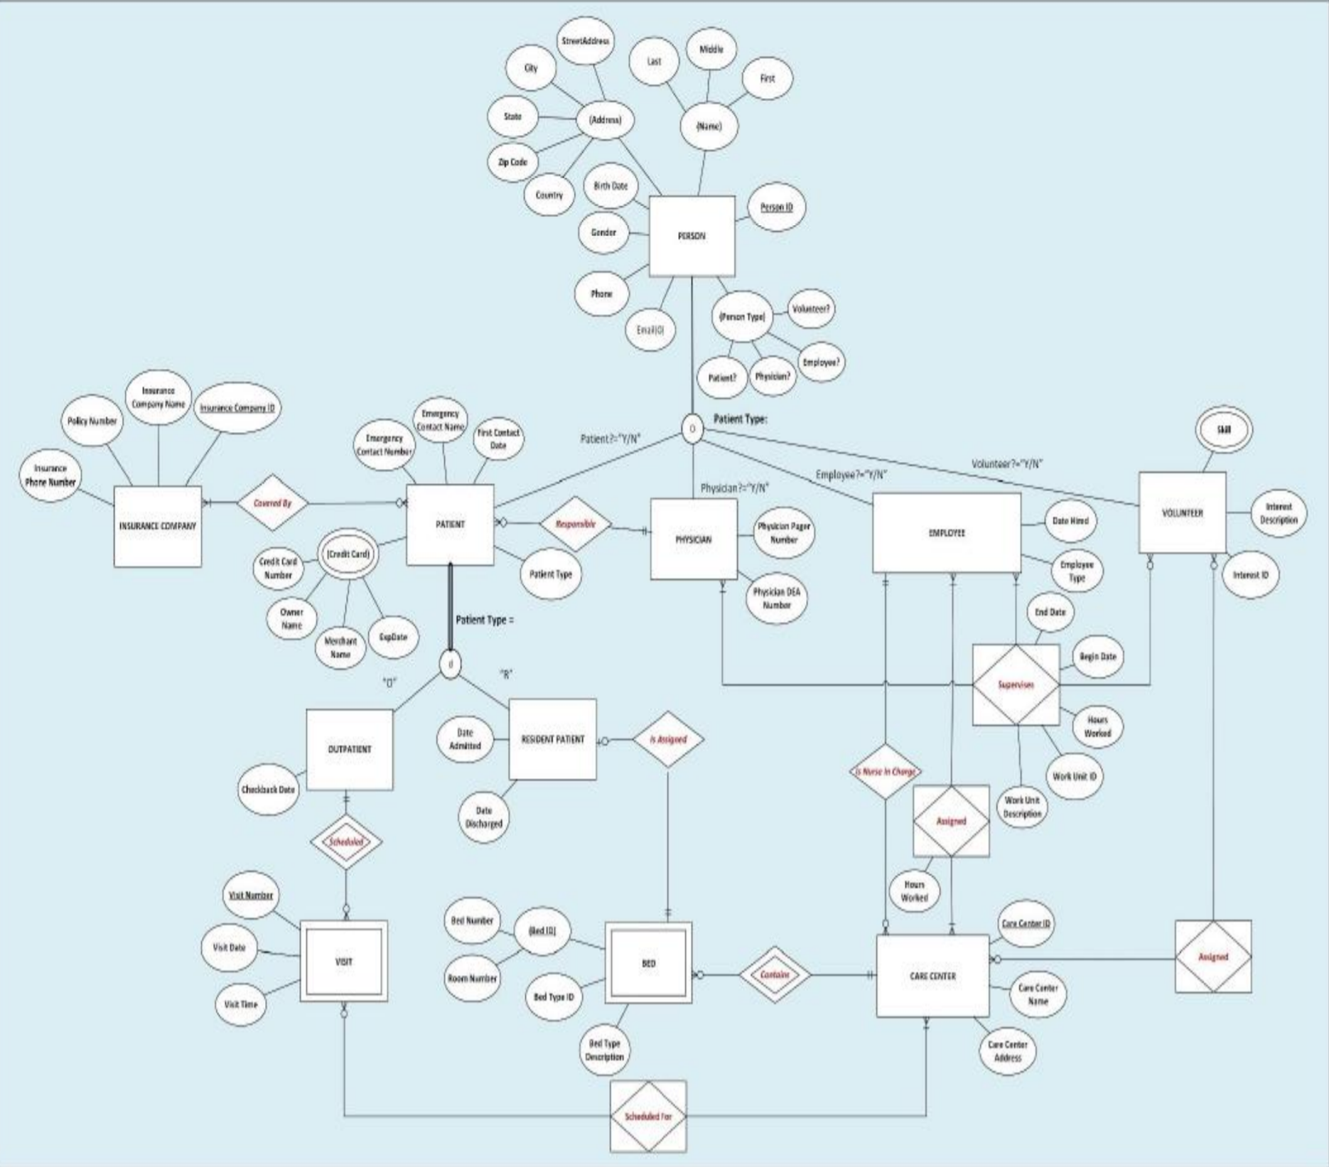

**Normalized Logical Model**

Below is the normalized logical model based on the conceptual ERD:

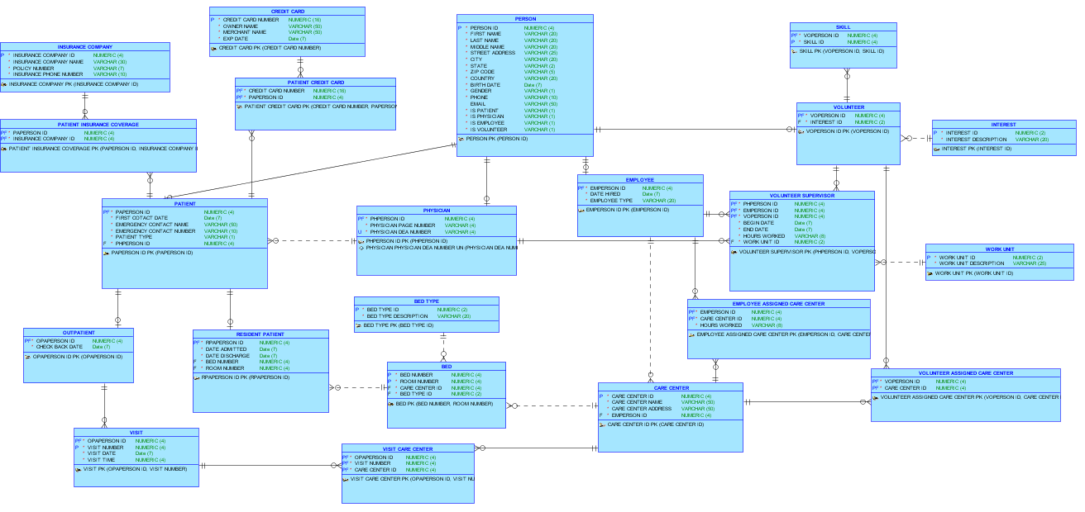

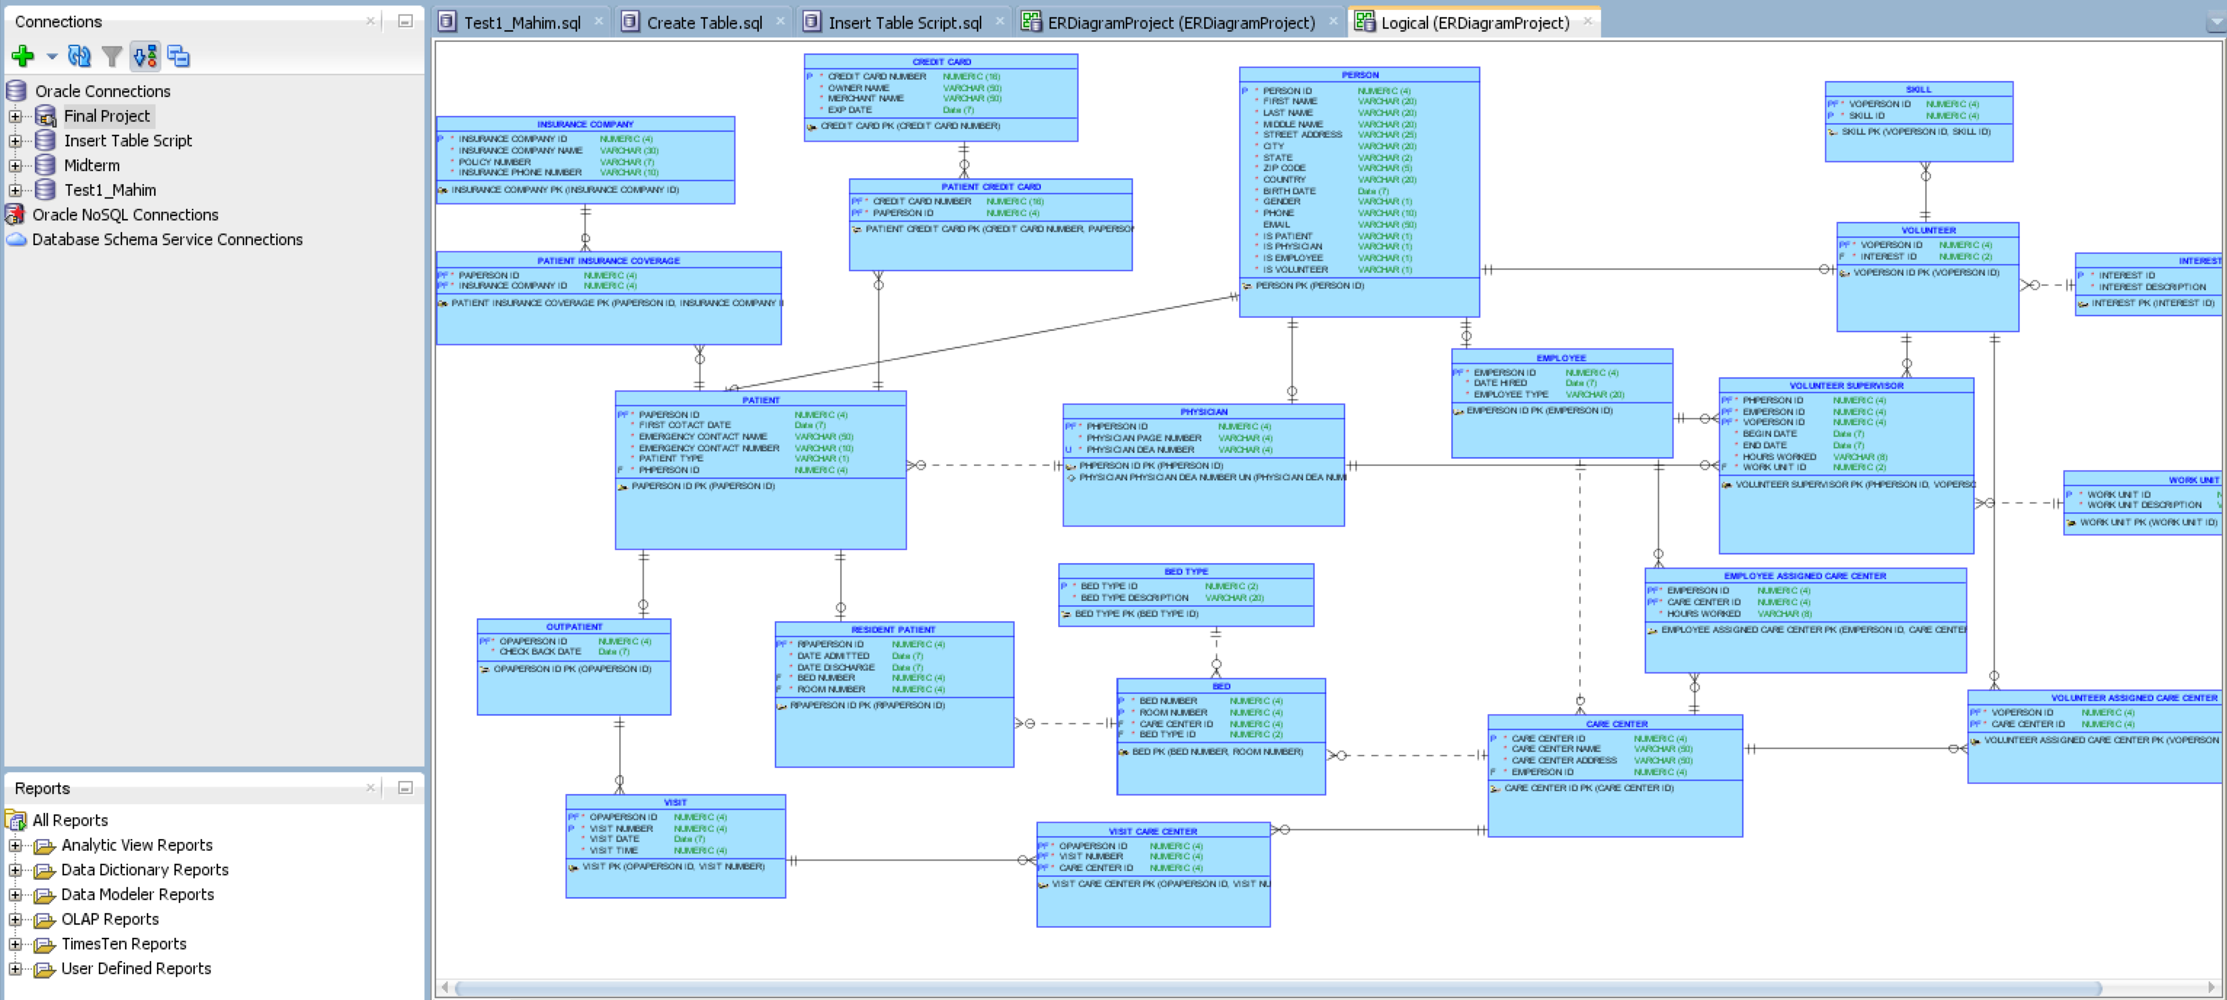

Now we have to create data dictionary based on this logical model.

**Data Dictionary**

Below are Data Dictionary based on the Normalized Logical Model:

**PERSON** TABLE

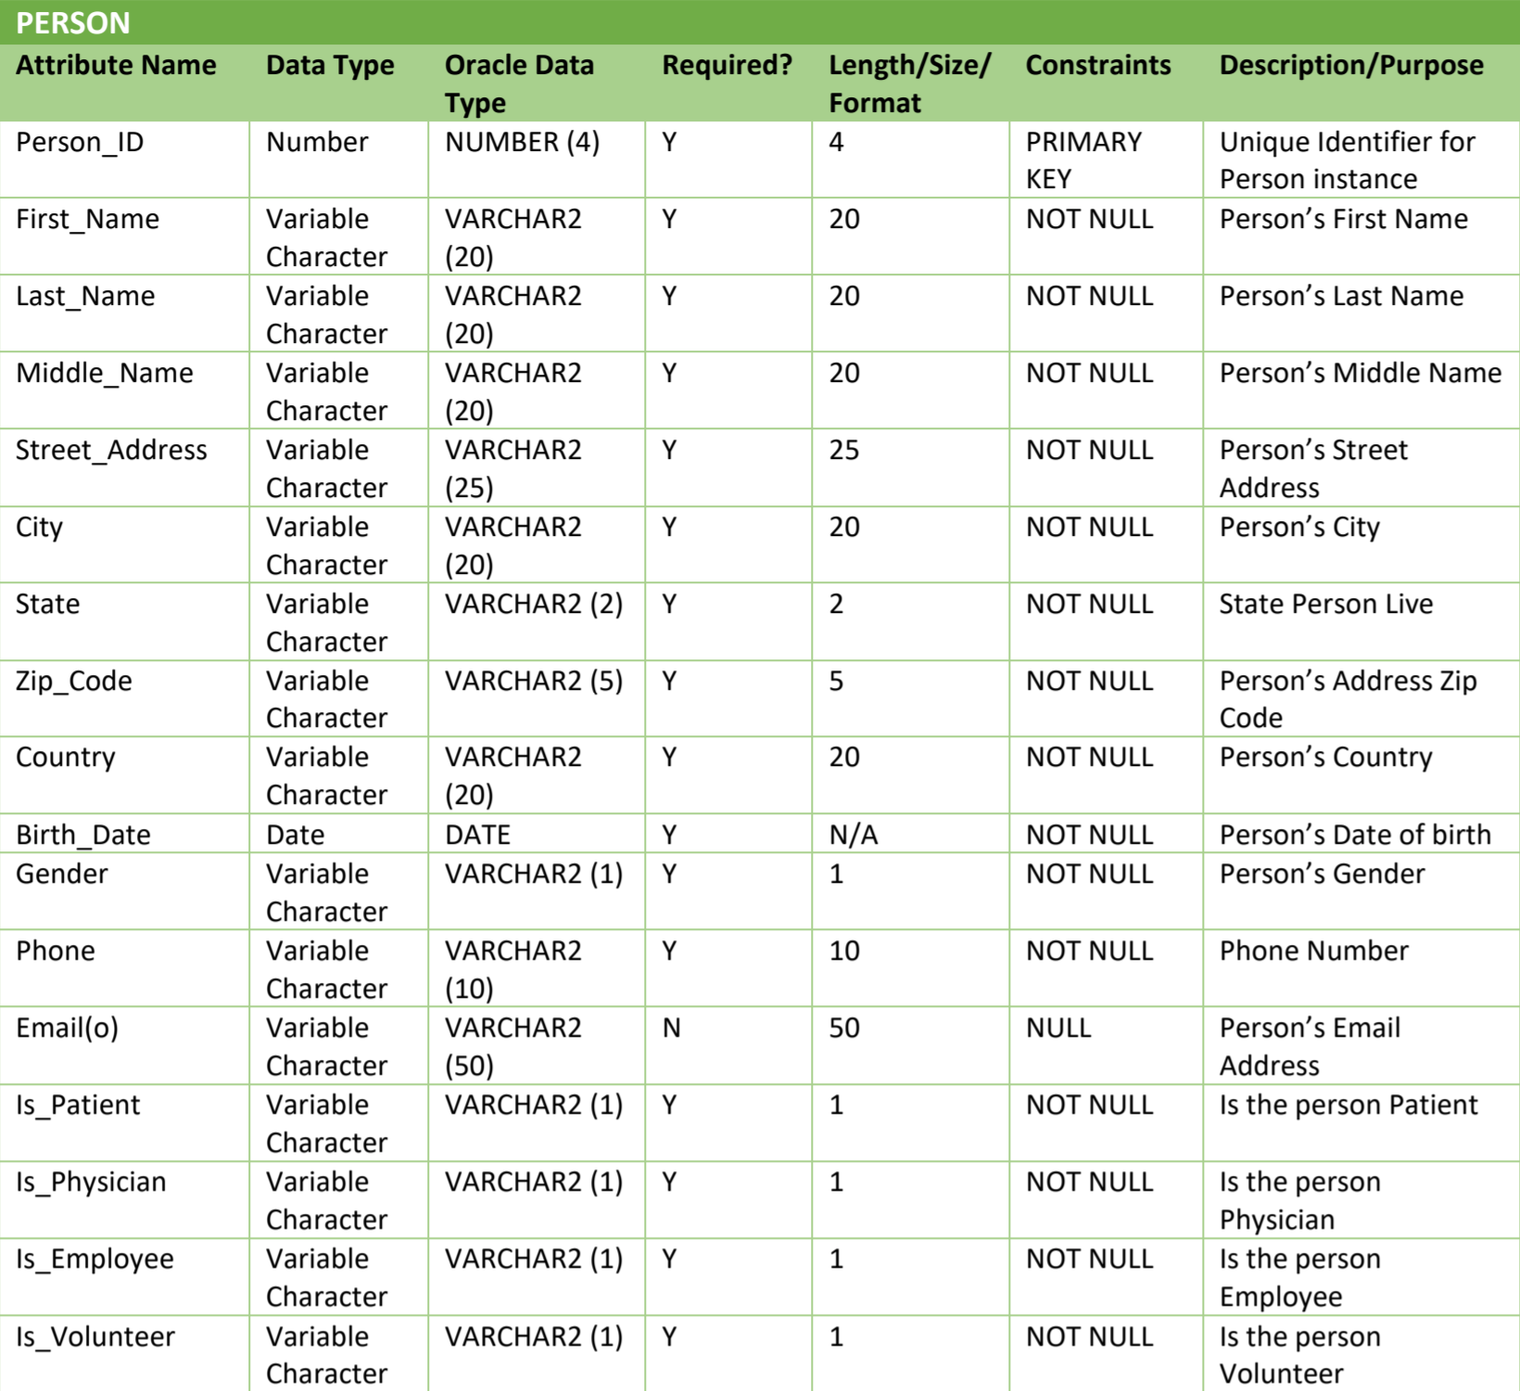

**Note**: Is_Patient, Is_Physician, Is_Employee, Is_Volunteer are considered YES/NO answer that’s why Oracle data type length 1 used. Also email address isn’t mandatory so it can be null.

**PHYSICIAN** TABLE

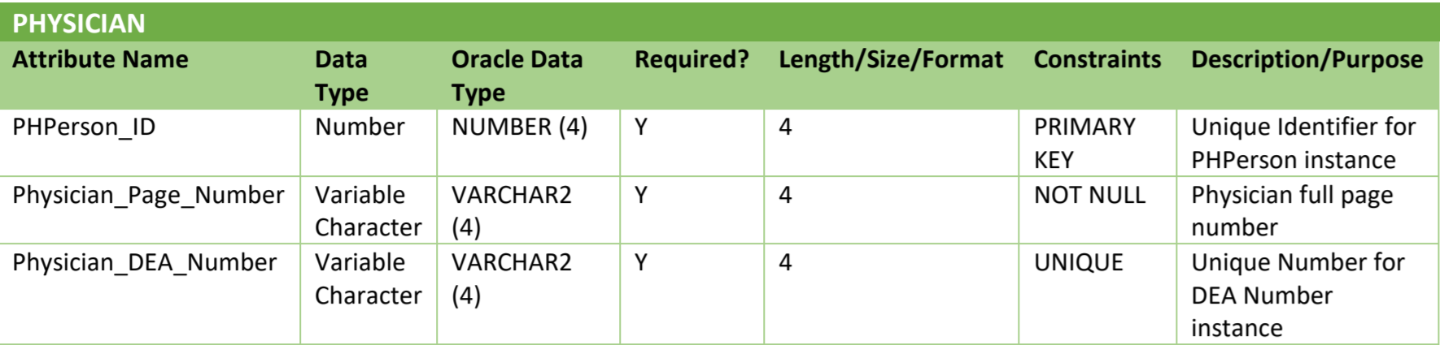

**EMPLOYEE** TABLE

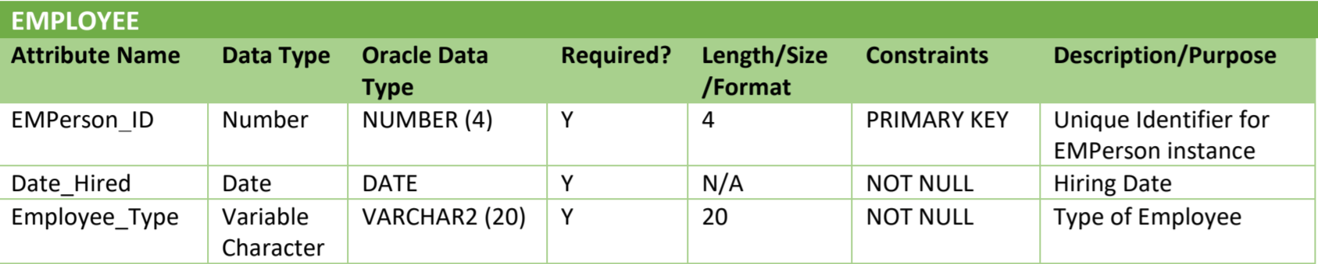

**INTEREST** TABLE

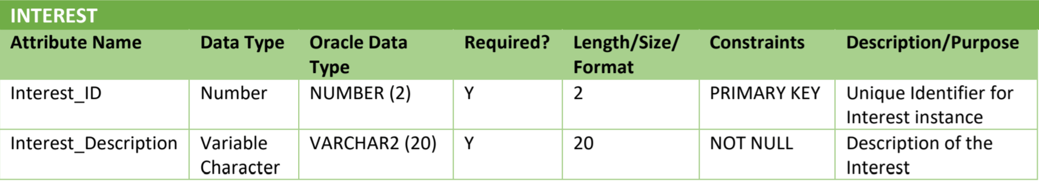

**Note**: We considered Volunteer can have more than 10 interests so Oracle data type length 2 used for Interest_ID.

**CREDIT_CARD** TABLE

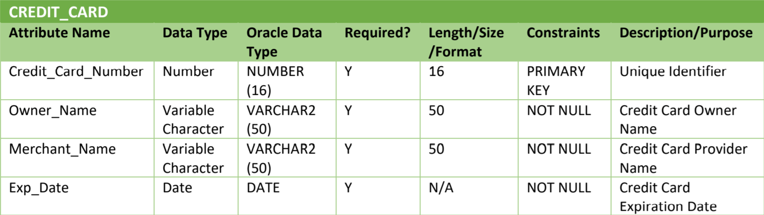

**PATIENT** TABLE

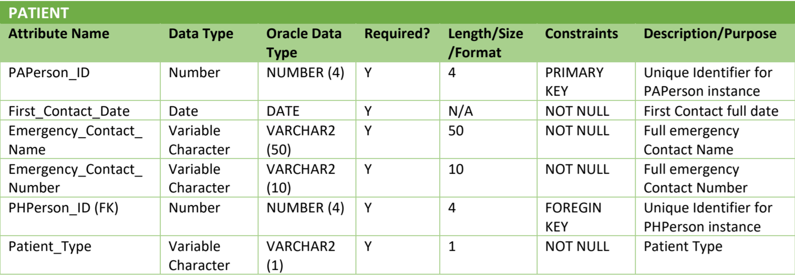

**Note**: Since Hospital has two types of patient Outpatient and Resident patient, that’s why Oracle data type length 1 used (for Outpatient “O” and Resident patient “R”).

**PATIENT_CREDIT_CARD** TABLE

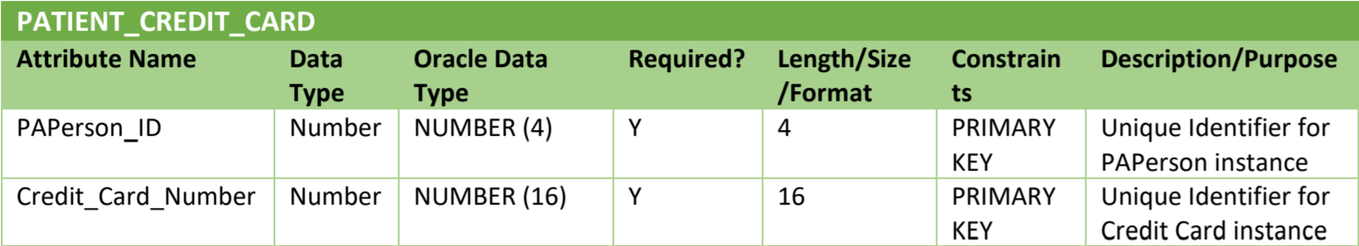

**INSURANCE_COMPANY** TABLE

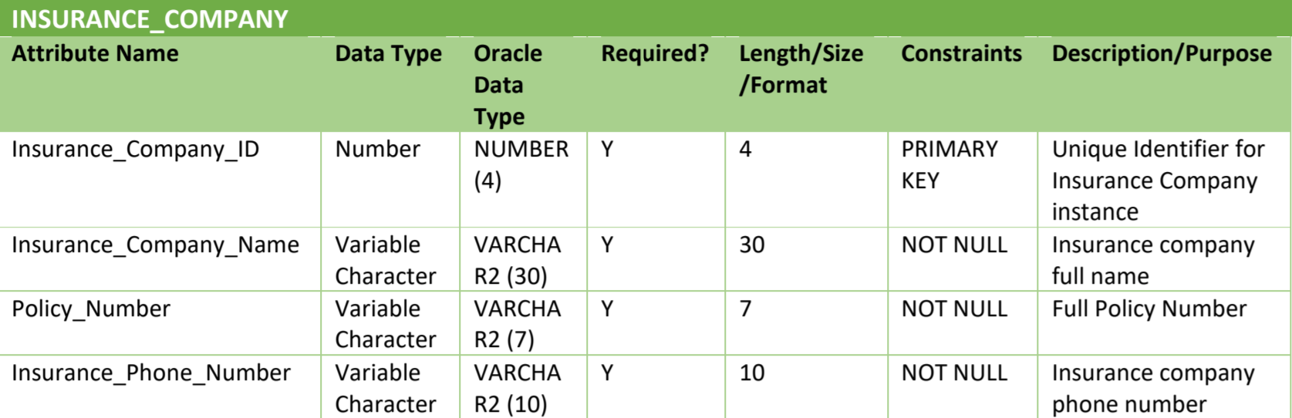

**PATIENT_INSURANCE_COVERAGE** TABLE

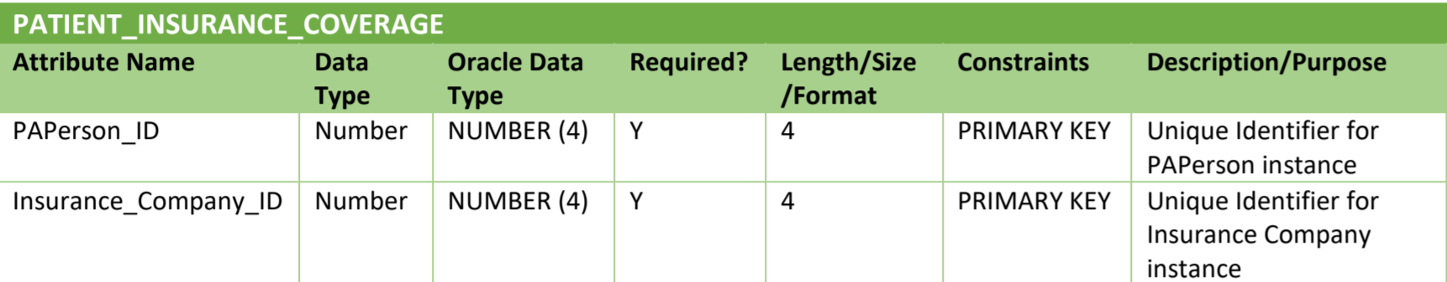

**VOLUNTEER** TABLE

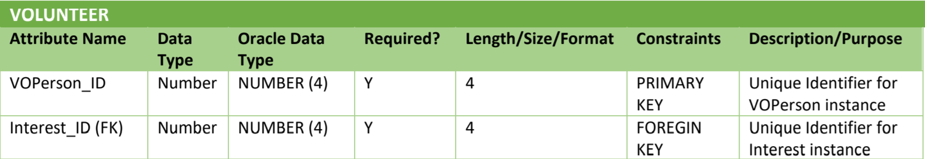

**SKILL** TABLE

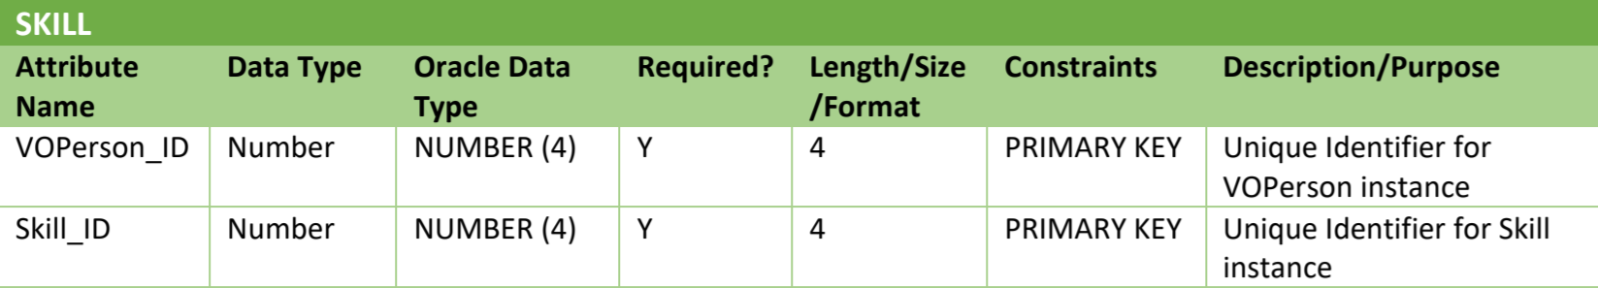

**OUTPATIENT** TABLE

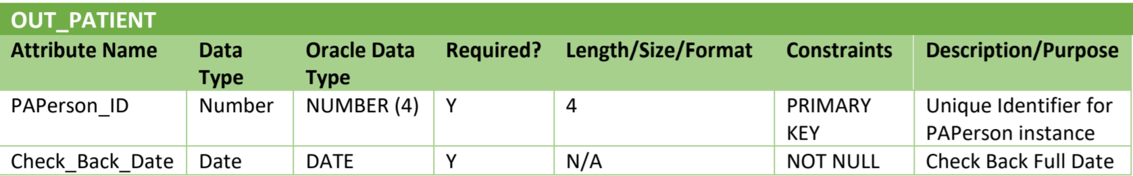

**VISIT** TABLE

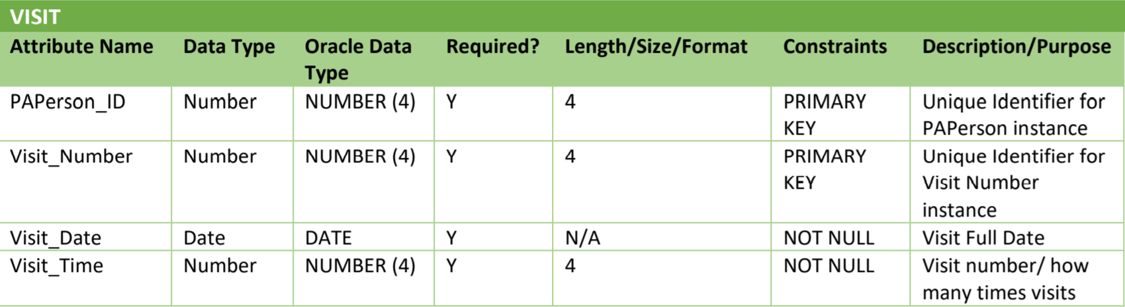

**CARE_CENTER** TABLE

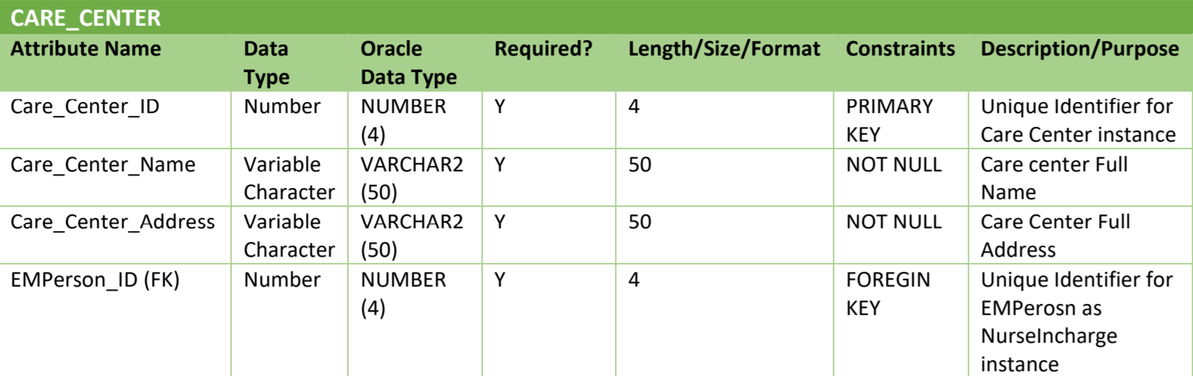

**VISIT_CARE_CENTER** TABLE

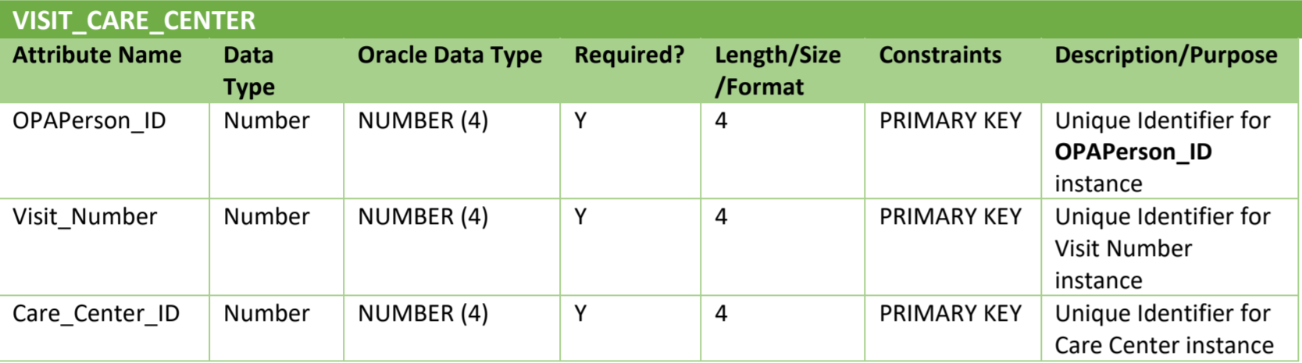

**BED_TYPE** TABLE

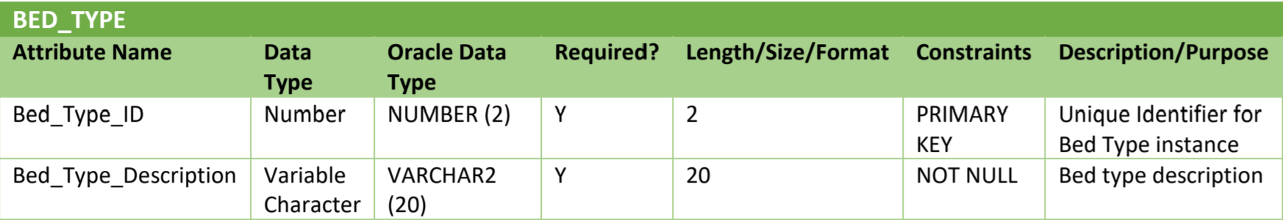

Note: We considered Hospital can have more than 10 types of bed so we used Oracle data type length 2 for Bed_Type_ID.

BED TABLE

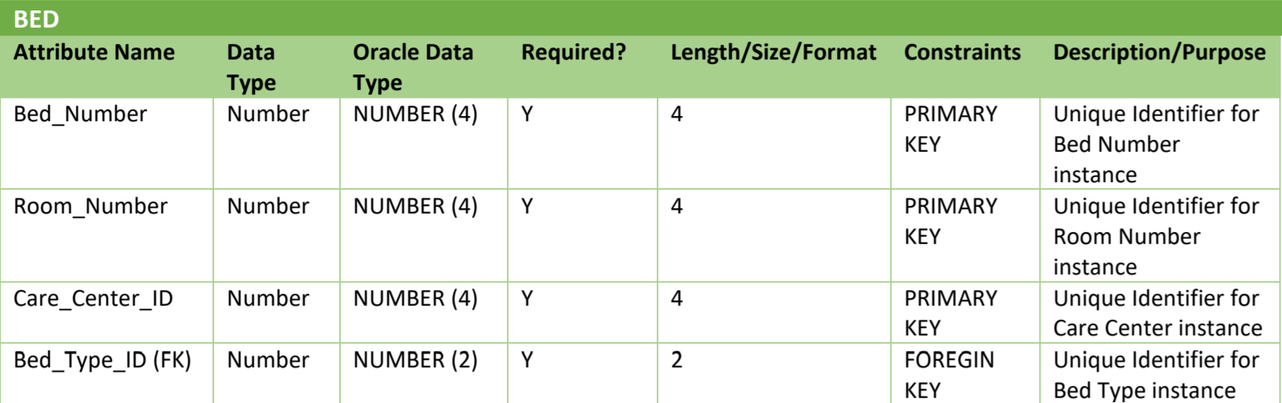

RESIDENT_PATIENT TABLE

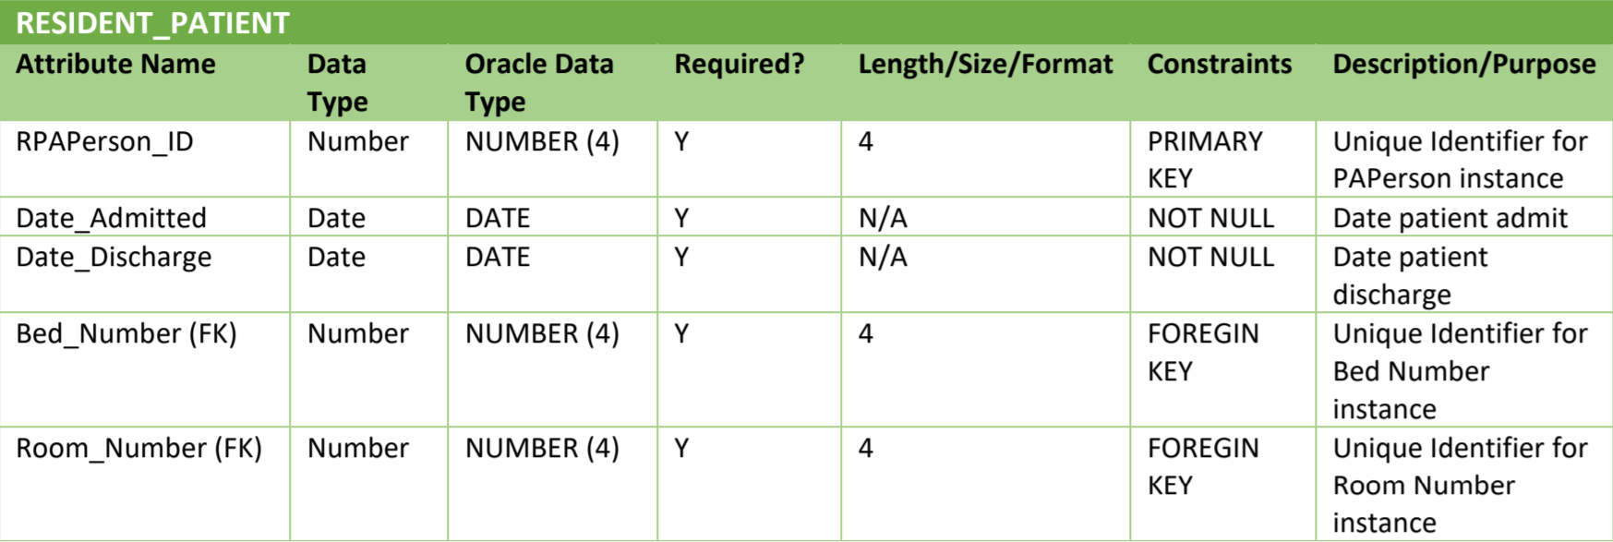

EMPLOYEE_ASSIGNED_CARE_CENTER TABLE

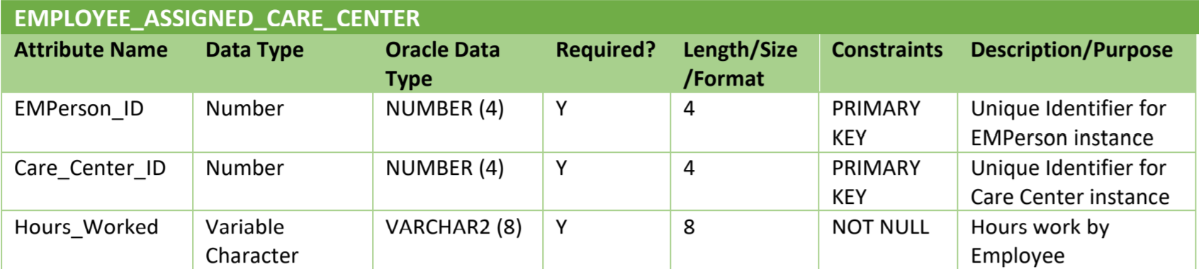

VOLUNTEER_ASSIGNED_CARE_CENTER TABLE

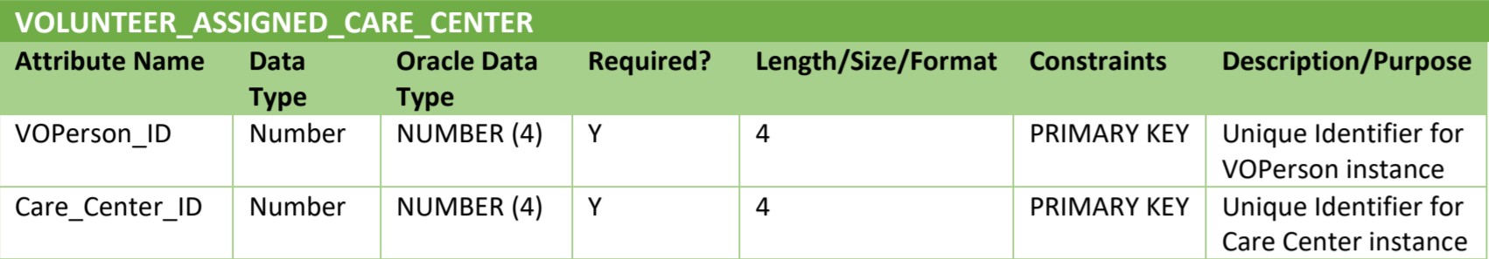

WORK_UNIT TABLE

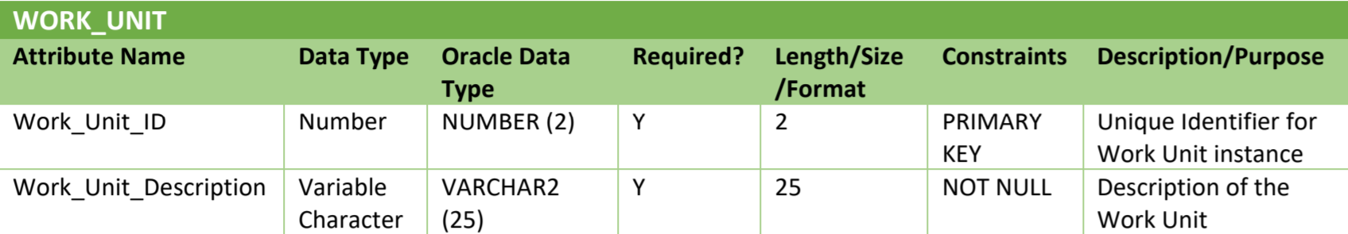

Note: We considered Hospital can have more than 10 work unit that’s why Oracle data type length 2 used for Work_unit_ID.

VOLUNTEER_SUPERVISOR TABLE

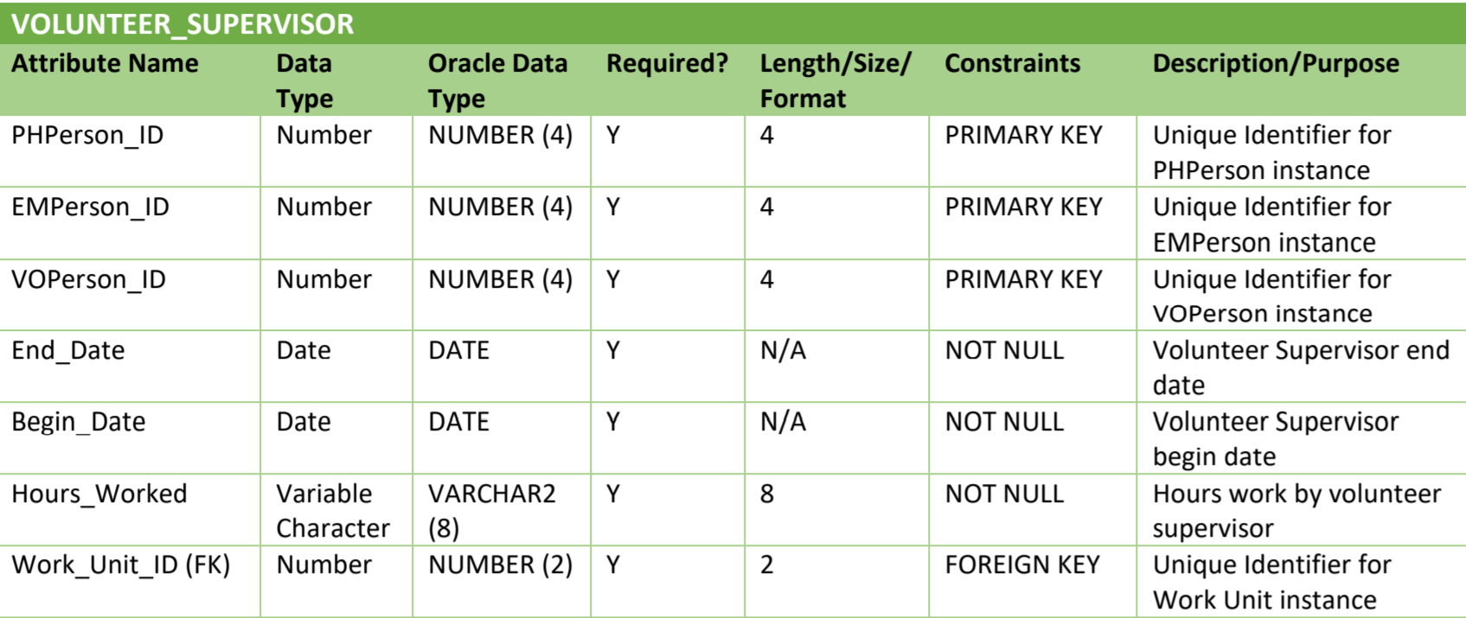

**Physical Model Schema Diagram**

Below is Physical Model Schema Diagram based on the Data Dictionary:

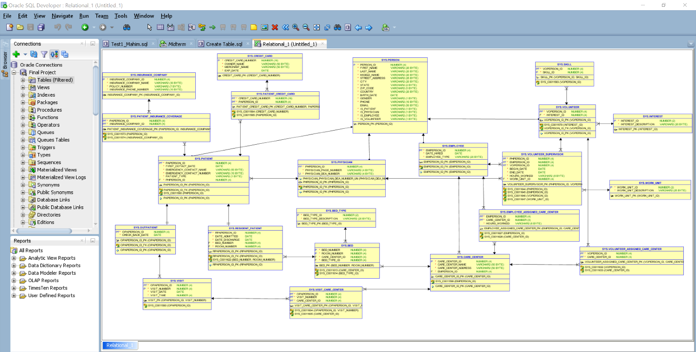

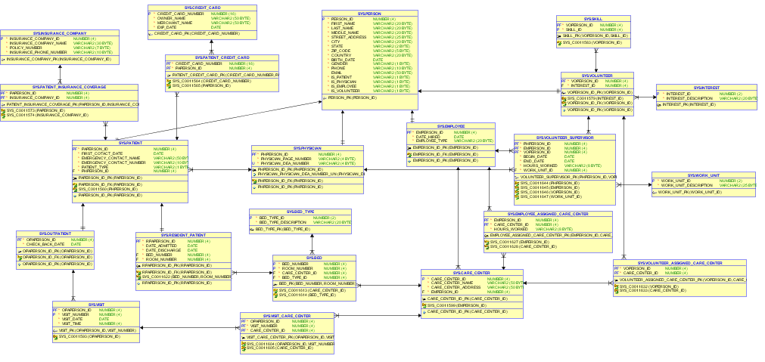

**Development & Implementation Phase – Script File**

Below are Create table Script files based on the Physical Model Schema Diagram:

**CREATE TABLE PERSON**

(

Person_ID NUMBER (4) PRIMARY KEY,

First_Name VARCHAR2 (20) NOT NULL,

Last_Name VARCHAR2 (20) NOT NULL,

Middle_Name VARCHAR2 (20) NOT NULL,

Street_Address VARCHAR2 (25) NOT NULL,

City VARCHAR2 (20) NOT NULL,

State VARCHAR2 (2) NOT NULL,

Zip_Code VARCHAR2 (5) NOT NULL,

Country VARCHAR2 (20) NOT NULL,

Birth_Date DATE NOT NULL,

Gender VARCHAR2 (1) NOT NULL,

Phone VARCHAR2 (10) NOT NULL,

Email VARCHAR2 (50) NULL,

Is_Patient VARCHAR2 (1) NOT NULL,

Is_Physician VARCHAR2 (1) NOT NULL,

Is_Employee VARCHAR2 (1) NOT NULL,

Is_Volunteer VARCHAR2 (1) NOT NULL

);

**CREATE TABLE PHYSICIAN**

(

PHPerson_ID NUMBER (4) NOT NULL,

Physician_Page_Number VARCHAR2 (4) NOT NULL,

Physician_DEA_Number VARCHAR2 (4) NOT NULL UNIQUE,

CONSTRAINT PHPerson_ID_PK PRIMARY KEY (PHPerson_ID),

CONSTRAINT PHPerson_ID_FK

FOREIGN KEY (PHPerson_ID)

REFERENCES PERSON(Person_ID)

);

**CREATE TABLE EMPLOYEE**

(

EMPerson_ID NUMBER (4) NOT NULL,

Date_Hired DATE NOT NULL,

Employee_Type VARCHAR2 (20) NOT NULL,

CONSTRAINT EMPerson_ID_PK PRIMARY KEY (EMPerson_ID),

CONSTRAINT EMPerson_ID_FK

FOREIGN KEY (EMPerson_ID)

REFERENCES PERSON(Person_ID)

);

**CREATE TABLE INTEREST**

(

Interest_ID NUMBER (2) PRIMARY KEY,

Interest_Description VARCHAR2 (20) NOT NULL

);

**CREATE TABLE CREDIT_CARD**

(

Credit_Card_Number NUMBER (16) PRIMARY KEY,

Owner_Name VARCHAR2 (50) NOT NULL,

Merchant_Name VARCHAR2 (50) NOT NULL,

Exp_Date DATE NOT NULL

);

**CREATE TABLE PATIENT**

(

PAPerson_ID NUMBER (4) NOT NULL,

First_Cotact_Date DATE NOT NULL,

Emergency_Contact_Name VARCHAR2 (50) NOT NULL,

Emergency_Contact_Number VARCHAR2 (10) NOT NULL,

Patient_Type VARCHAR2 (1) NOT NULL,

PHPerson_ID NUMBER (4) NOT NULL,

CONSTRAINT PAPerson_ID_PK PRIMARY KEY (PAPerson_ID),

CONSTRAINT PAPerson_ID_FK

FOREIGN KEY (PAPerson_ID)

REFERENCES PERSON(Person_ID),

FOREIGN KEY (PHPerson_ID)

REFERENCES PHYSICIAN(PHPerson_ID)

);

**CREATE TABLE PATIENT_CREDIT_CARD**

(

Credit_Card_Number NUMBER (16) NOT NULL,

PAPerson_ID NUMBER (4) NOT NULL,

PRIMARY KEY (Credit_Card_Number,PAPerson_ID),

FOREIGN KEY (Credit_Card_Number)

REFERENCES CREDIT_CARD(Credit_Card_Number),

FOREIGN KEY (PAPerson_ID)

REFERENCES PATIENT(PAPerson_ID)

);

**CREATE TABLE INSURANCE_COMPANY**

(

Insurance_Company_ID NUMBER (4) PRIMARY KEY,

Insurance_Company_Name VARCHAR2 (30) NOT NULL,

Policy_Number VARCHAR2 (7) NOT NULL,

Insurance_Phone_Number VARCHAR2 (10) NOT NULL

);

**CREATE TABLE PATIENT_INSURANCE_COVERAGE**

(

PAPerson_ID NUMBER (4) NOT NULL,

Insurance_Company_ID NUMBER (4) NOT NULL,

PRIMARY KEY (PAPerson_ID,Insurance_Company_ID),

FOREIGN KEY (PAPerson_ID)

REFERENCES PATIENT(PAPerson_ID),

FOREIGN KEY (Insurance_Company_ID)

REFERENCES INSURANCE_COMPANY(Insurance_Company_ID)

);

**CREATE TABLE VOLUNTEER**

(

VOPerson_ID NUMBER (4) NOT NULL,

Interest_ID NUMBER (4) NOT NULL,

CONSTRAINT VOPerson_ID_PK PRIMARY KEY (VOPerson_ID),

CONSTRAINT VOPerson_ID_FK

FOREIGN KEY (VOPerson_ID)

REFERENCES PERSON(Person_ID),

FOREIGN KEY (Interest_ID)

REFERENCES INTEREST(Interest_ID)

);

**CREATE TABLE SKILL**

(

VOPerson_ID NUMBER (4) NOT NULL,

Skill_ID NUMBER (4) NOT NULL,

PRIMARY KEY (VOPerson_ID,Skill_ID),

FOREIGN KEY (VOPerson_ID)

REFERENCES VOLUNTEER(VOPerson_ID)

);

**CREATE TABLE OUTPATIENT**

(

OPAPerson_ID NUMBER (4) NOT NULL,

Check_Back_DATE DATE NOT NULL,

CONSTRAINT OPAPerson_ID_PK PRIMARY KEY (OPAPerson_ID),

CONSTRAINT OPAPerson_ID_FK

FOREIGN KEY (OPAPerson_ID)

REFERENCES PATIENT(PAPerson_ID)

);

**CREATE TABLE VISIT**

(

OPAPerson_ID NUMBER (4) NOT NULL,

Visit_Number NUMBER (4) NOT NULL,

Visit_Date DATE NOT NULL,

Visit_Time NUMBER (4) NOT NULL,

PRIMARY KEY (OPAPerson_ID,Visit_Number),

FOREIGN KEY (OPAPerson_ID)

REFERENCES OUTPATIENT(OPAPerson_ID)

);

**CREATE TABLE CARE_CENTER**

(

Care_Center_ID NUMBER (4) NOT NULL,

Care_Center_Name VARCHAR2 (50) NOT NULL,

Care_Center_Address VARCHAR2 (50) NOT NULL,

EMPerson_ID NUMBER (4) NOT NULL,

CONSTRAINT Care_Center_ID_PK PRIMARY KEY (Care_Center_ID),

FOREIGN KEY (EMPerson_ID)

REFERENCES EMPLOYEE(EMPerson_ID)

);

**CREATE TABLE VISIT_CARE_CENTER**

(

OPAPerson_ID NUMBER (4) NOT NULL,

Visit_Number NUMBER (4) NOT NULL,

Care_Center_ID NUMBER (4) NOT NULL,

PRIMARY KEY (OPAPerson_ID,Visit_Number,Care_Center_ID),

FOREIGN KEY (OPAPerson_ID,Visit_Number)

REFERENCES VISIT(OPAPerson_ID,Visit_Number),

FOREIGN KEY (Care_Center_ID)

REFERENCES CARE_CENTER(Care_Center_ID)

);

**CREATE TABLE BED_TYPE**

(

Bed_Type_ID NUMBER (2) PRIMARY KEY,

Bed_Type_Description VARCHAR2 (20) NOT NULL

);

**CREATE TABLE BED**

(

Bed_Number NUMBER (4) NOT NULL,

Room_Number NUMBER (4) NOT NULL,

Care_Center_ID NUMBER (4) NOT NULL,

Bed_Type_ID NUMBER (4) NOT NULL,

PRIMARY KEY (Bed_Number,Room_Number),

FOREIGN KEY (Care_Center_ID)

REFERENCES CARE_CENTER(Care_Center_ID),

FOREIGN KEY (Bed_Type_ID)

REFERENCES BED_TYPE(Bed_Type_ID)

);

**CREATE TABLE RESIDENT_PATIENT**

(

RPAPerson_ID NUMBER (4) NOT NULL,

Date_Admitted DATE NOT NULL,

Date_Discharge DATE NOT NULL,

Bed_Number NUMBER (4) NOT NULL,

Room_Number NUMBER (4) NOT NULL,

CONSTRAINT RPAPerson_ID_PK PRIMARY KEY (RPAPerson_ID),

CONSTRAINT RPAPerson_ID_FK

FOREIGN KEY (RPAPerson_ID)

REFERENCES PATIENT(PAPerson_ID),

FOREIGN KEY (Bed_Number,Room_Number)

REFERENCES BED(Bed_Number,Room_Number)

);

**CREATE TABLE EMPLOYEE_ASSIGNED_CARE_CENTER**

(

EMPerson_ID NUMBER (4) NOT NULL,

Care_Center_ID NUMBER (4) NOT NULL,

Hours_Worked VARCHAR2 (8) NOT NULL,

PRIMARY KEY (EMPerson_ID,Care_Center_ID),

FOREIGN KEY (EMPerson_ID)

REFERENCES EMPLOYEE(EMPerson_ID),

FOREIGN KEY (Care_Center_ID)

REFERENCES CARE_CENTER(Care_Center_ID)

);

**CREATE TABLE VOLUNTEER_ASSIGNED_CARE_CENTER**

(

VOPerson_ID NUMBER (4) NOT NULL,

Care_Center_ID NUMBER (4) NOT NULL,

PRIMARY KEY (VOPerson_ID,Care_Center_ID),

FOREIGN KEY (VOPerson_ID)

REFERENCES VOLUNTEER(VOPerson_ID),

FOREIGN KEY (Care_Center_ID)

REFERENCES CARE_CENTER(Care_Center_ID)

);

**CREATE TABLE WORK_UNIT**

(

Work_Unit_ID NUMBER (2) PRIMARY KEY,

Work_Unit_Description VARCHAR2 (25) NOT NULL

);

**CREATE TABLE VOLUNTEER_SUPERVISOR**

(

PHPerson_ID NUMBER (4) NOT NULL,

EMPerson_ID NUMBER (4) NOT NULL,

VOPerson_ID NUMBER (4) NOT NULL,

Begin_Date DATE NOT NULL,

End_Date DATE NOT NULL,

Hours_Worked VARCHAR2 (8) NOT NULL,

Work_Unit_ID NUMBER (4) NOT NULL,

PRIMARY KEY (PHPerson_ID,VOPerson_ID,EMPerson_ID),

FOREIGN KEY (PHPerson_ID)

REFERENCES PHYSICIAN(PHPerson_ID),

FOREIGN KEY (EMPerson_ID)

REFERENCES EMPLOYEE(EMPerson_ID),

FOREIGN KEY (VOPerson_ID)

REFERENCES VOLUNTEER(VOPerson_ID),

FOREIGN KEY (Work_Unit_ID)

REFERENCES WORK_UNIT(Work_Unit_ID)

);

**Testing and Validating Via Queries**

***Testing with INSERT statements:***

**PERSON** Table Data Inserted

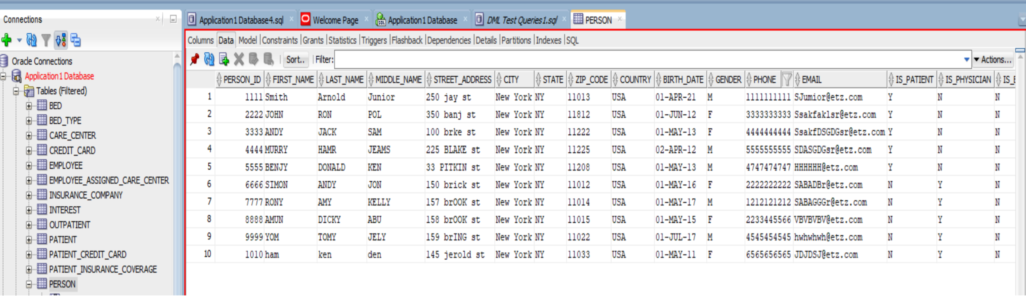

**PHYSICIAN** Table Data Inserted

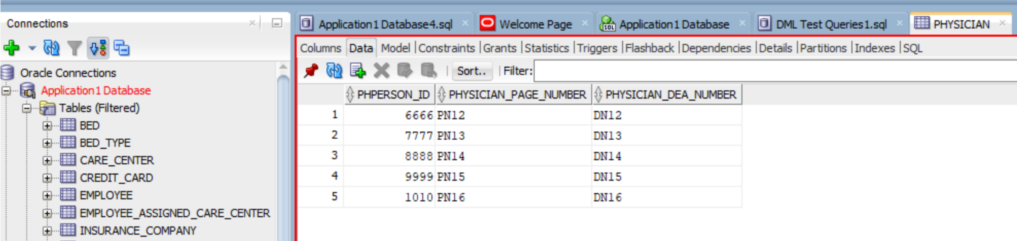

**PATIENT** Table Data Inserted

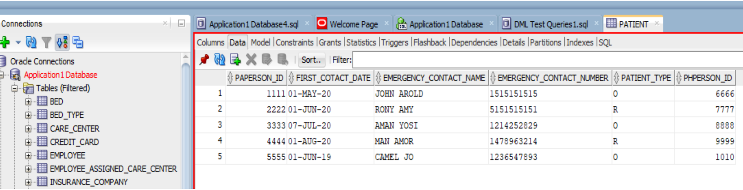

**CREDIT_CARD** Table Data Inserted

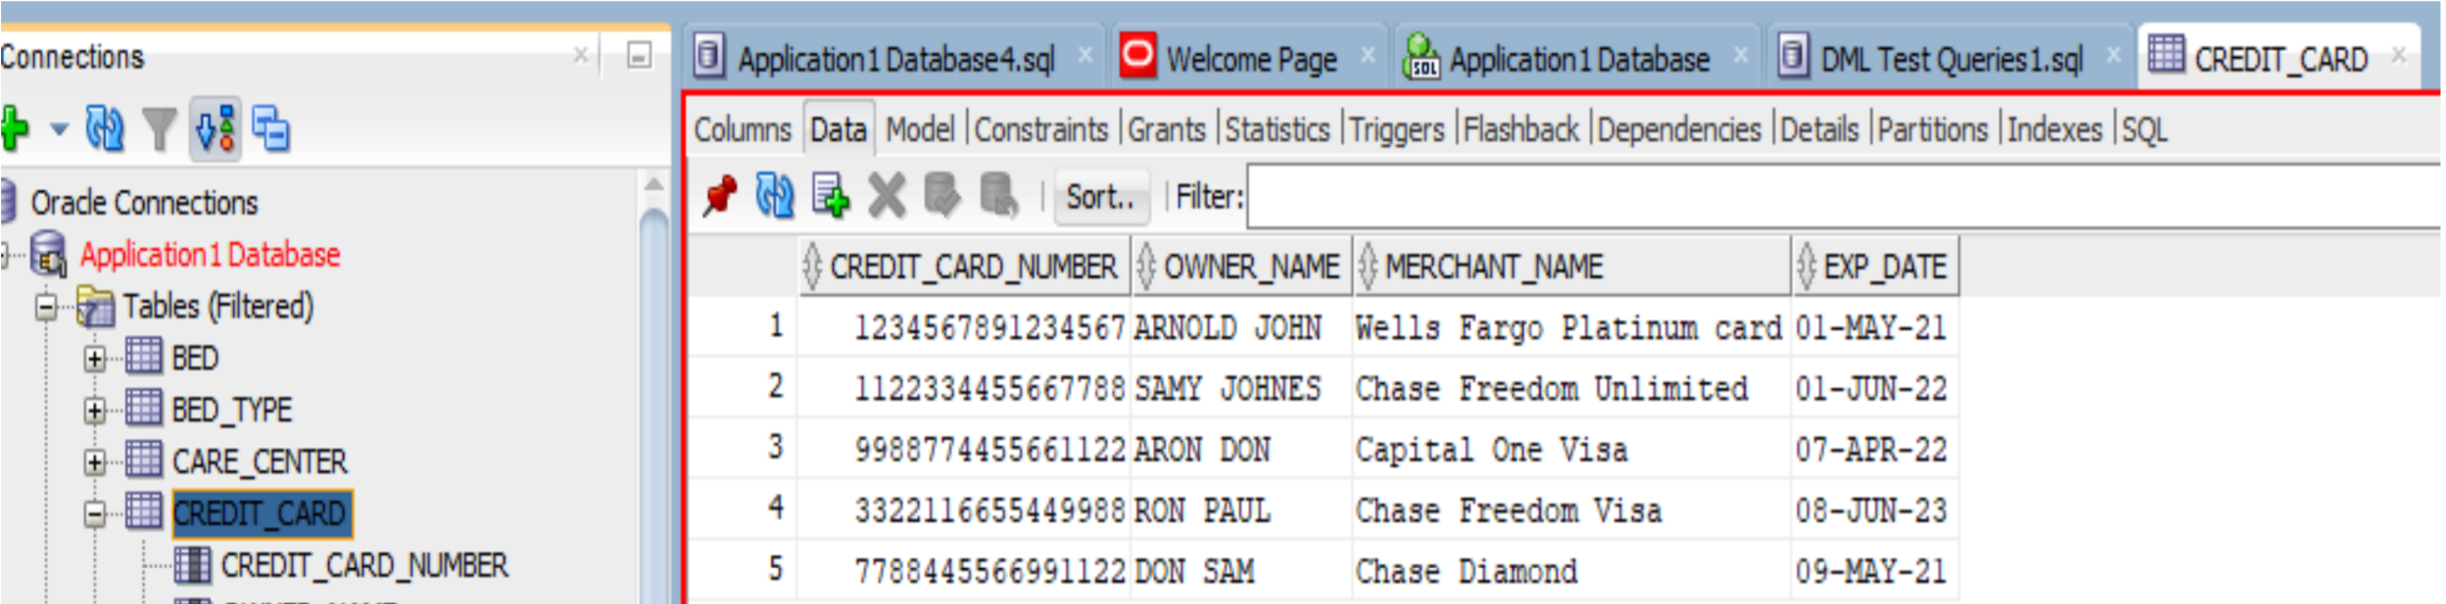

**PATIENT_CREDIT_CARD** Table Data Inserted

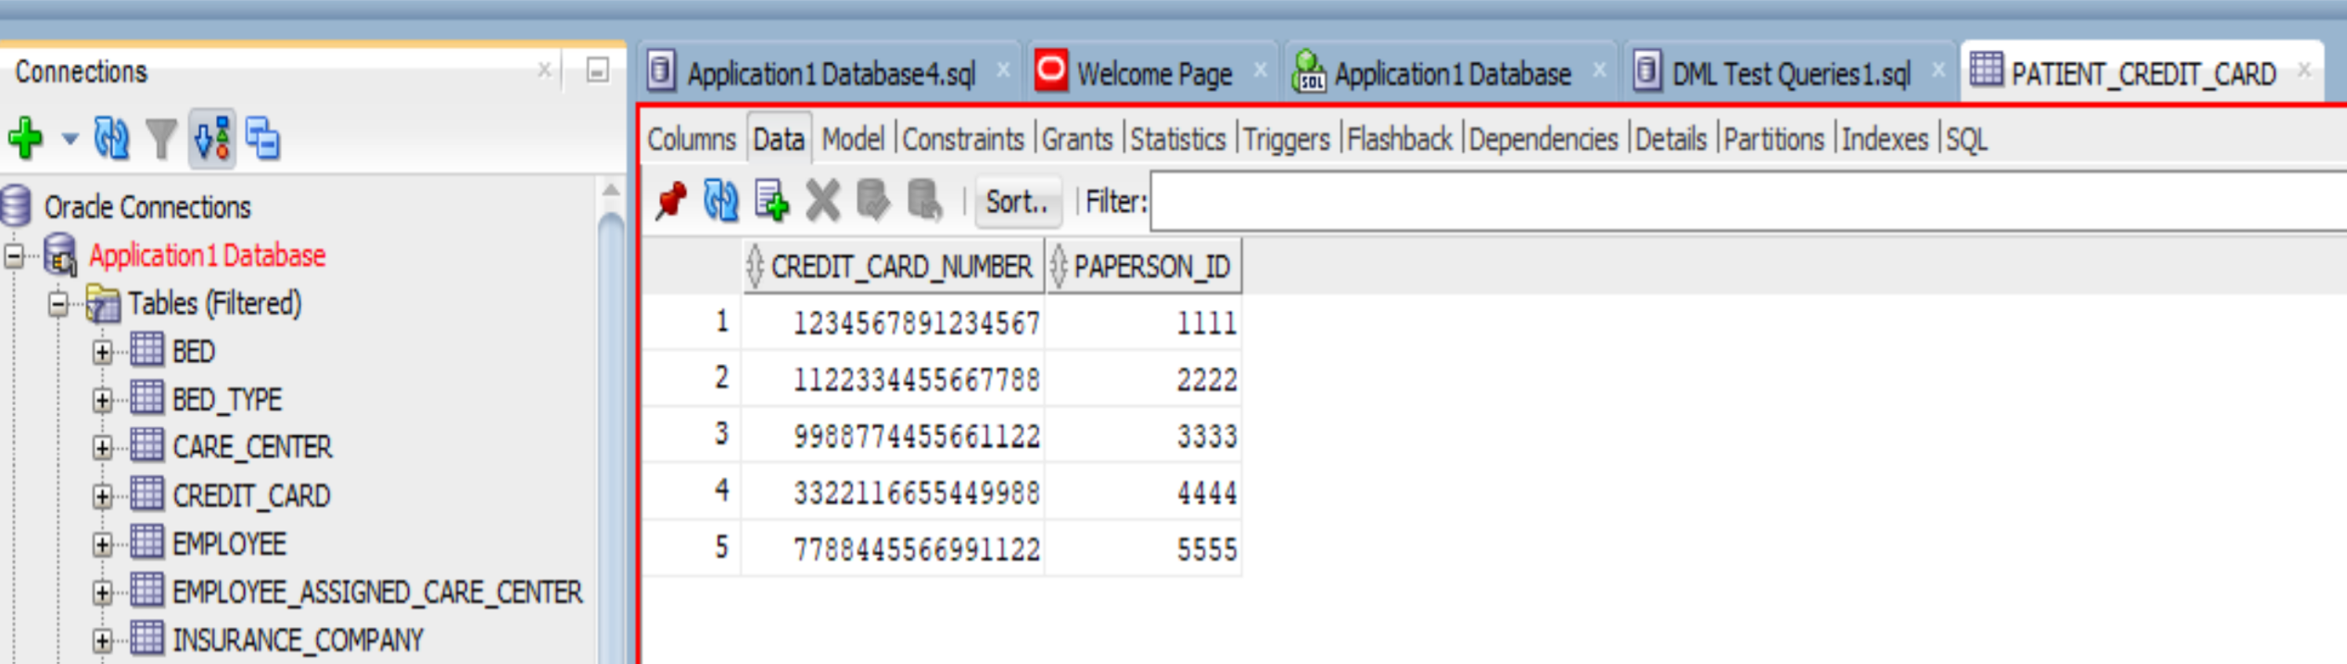

**INSURANCE_COMPANY** Table Data Inserted

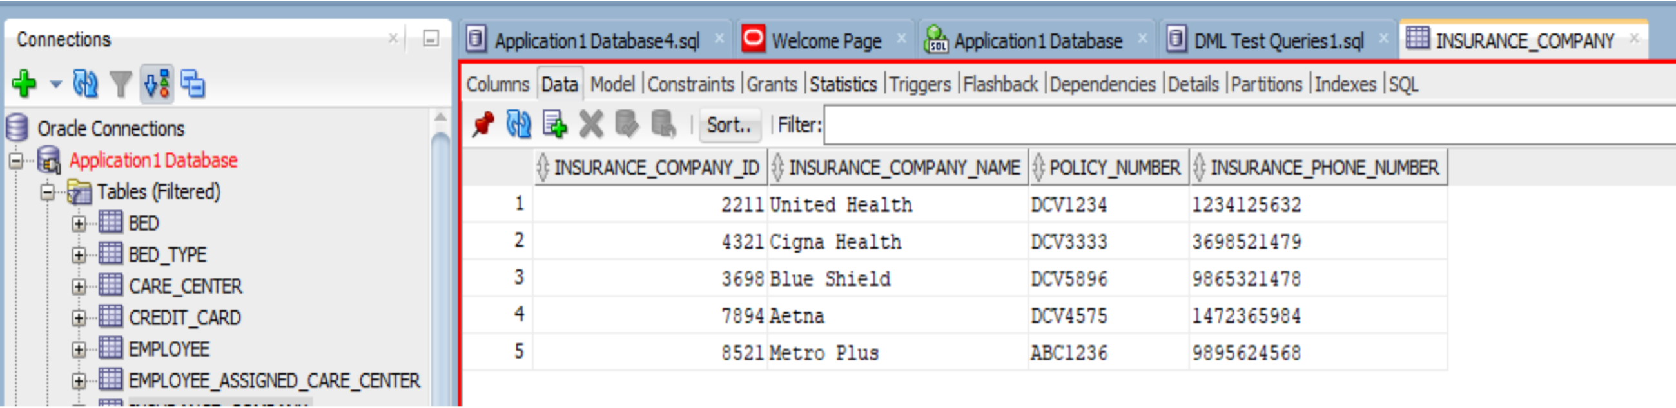

**PATIENT_INSURANCE_COVERAGE** Table Data Inserted

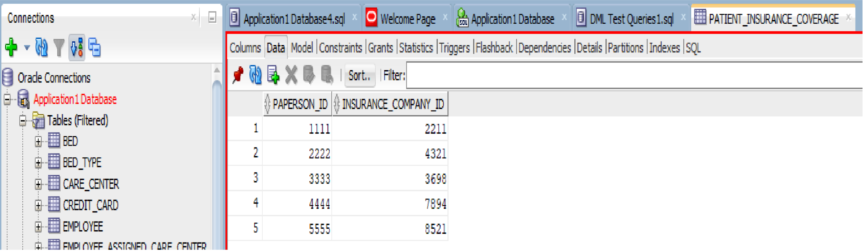

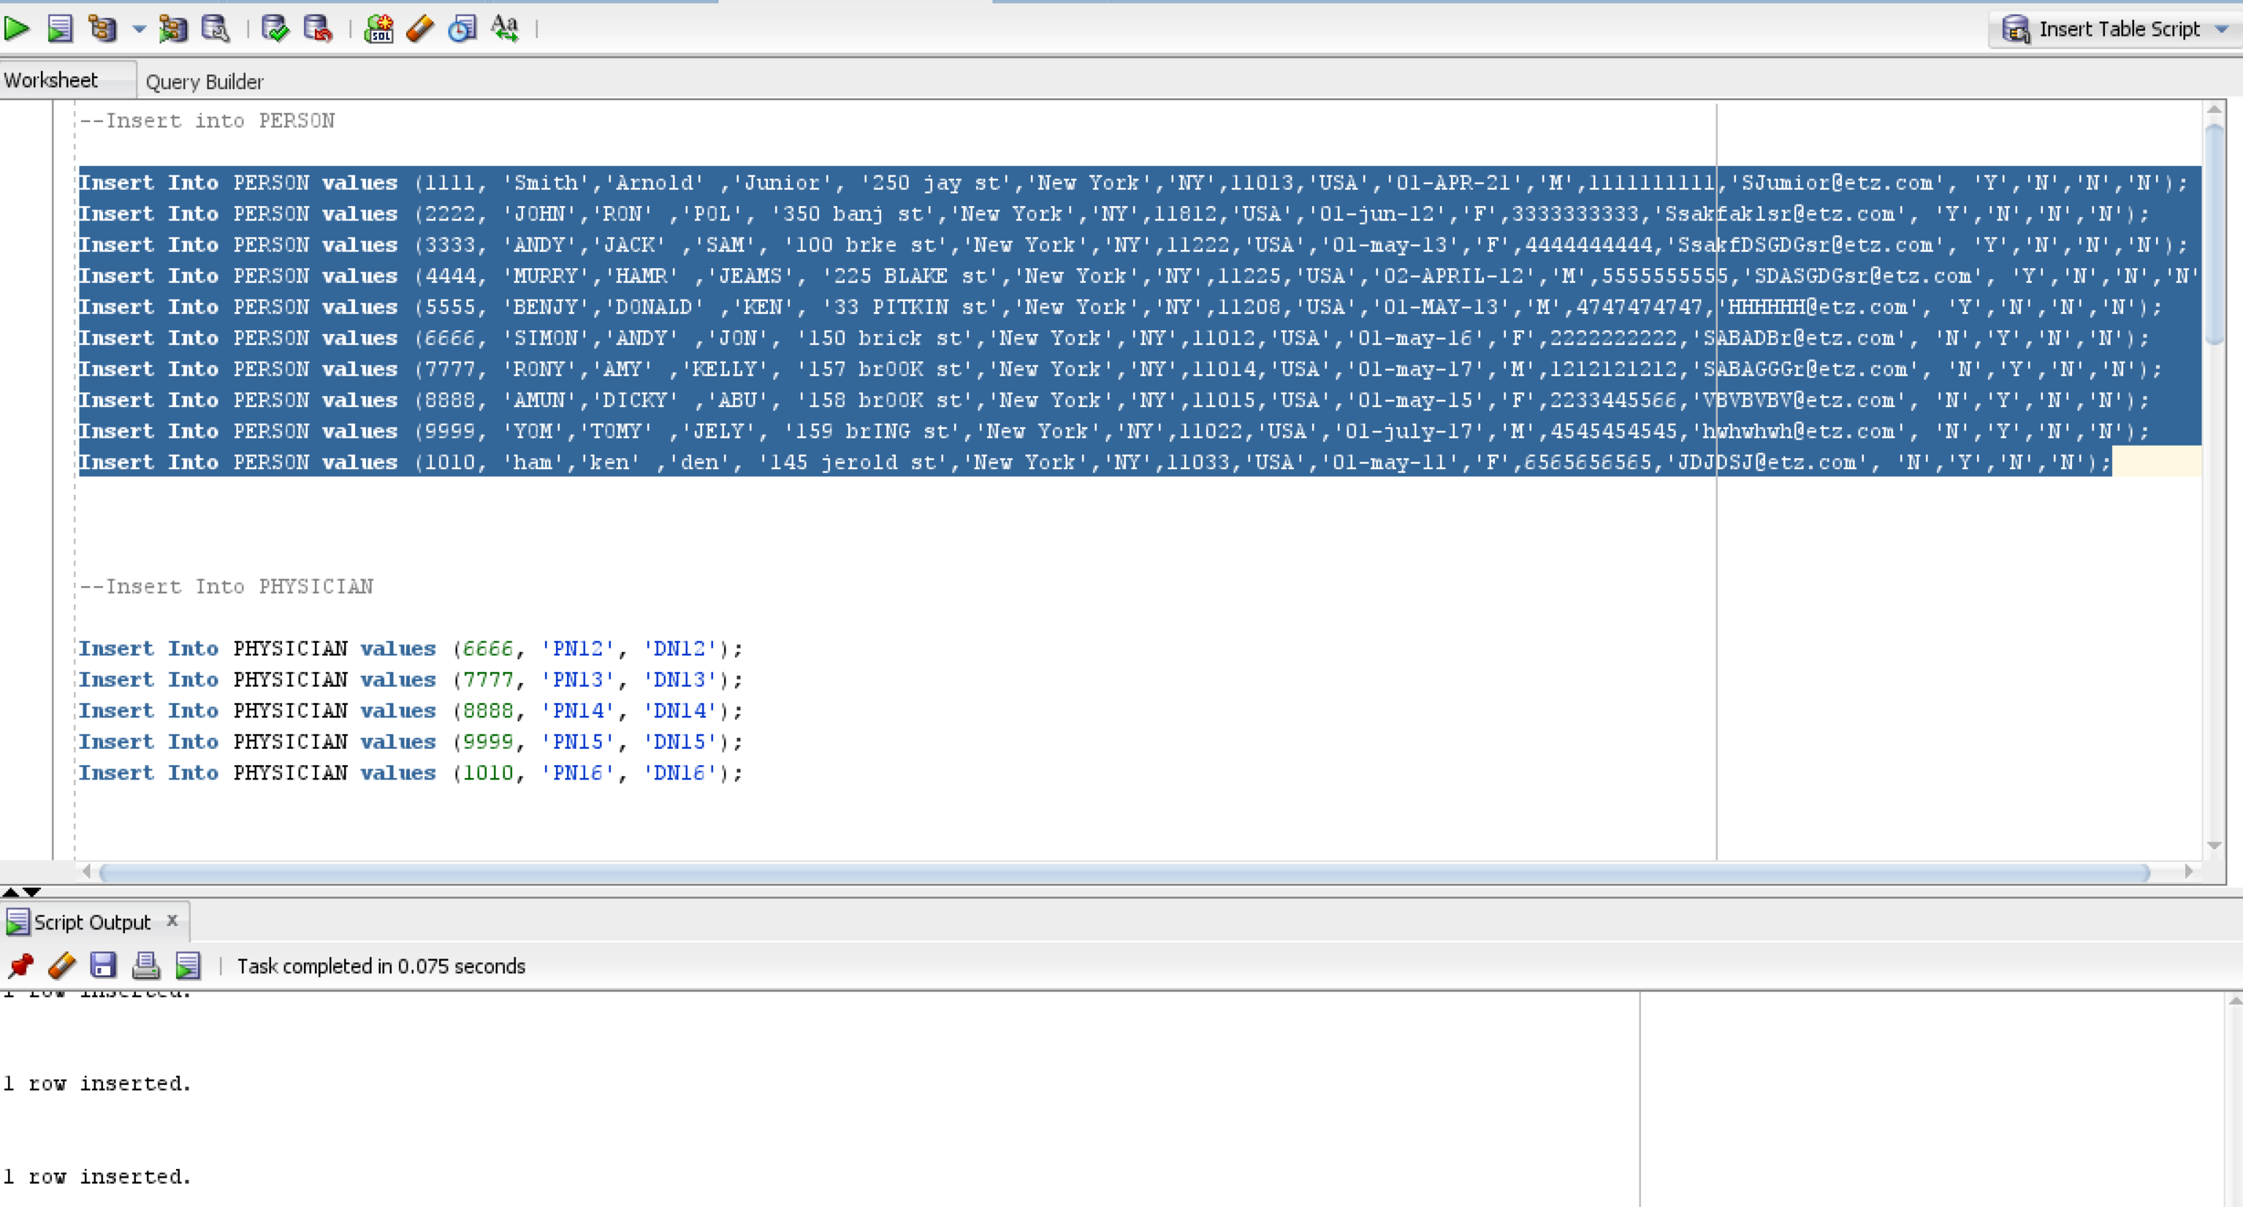

***Testing with SELECT statements:***

Displaying one record based on Primary Key

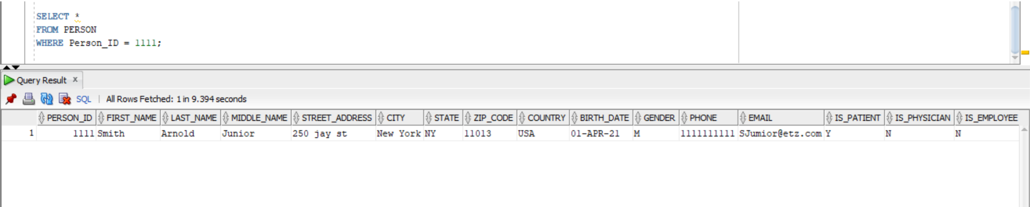

Displaying multiple records based on criteria

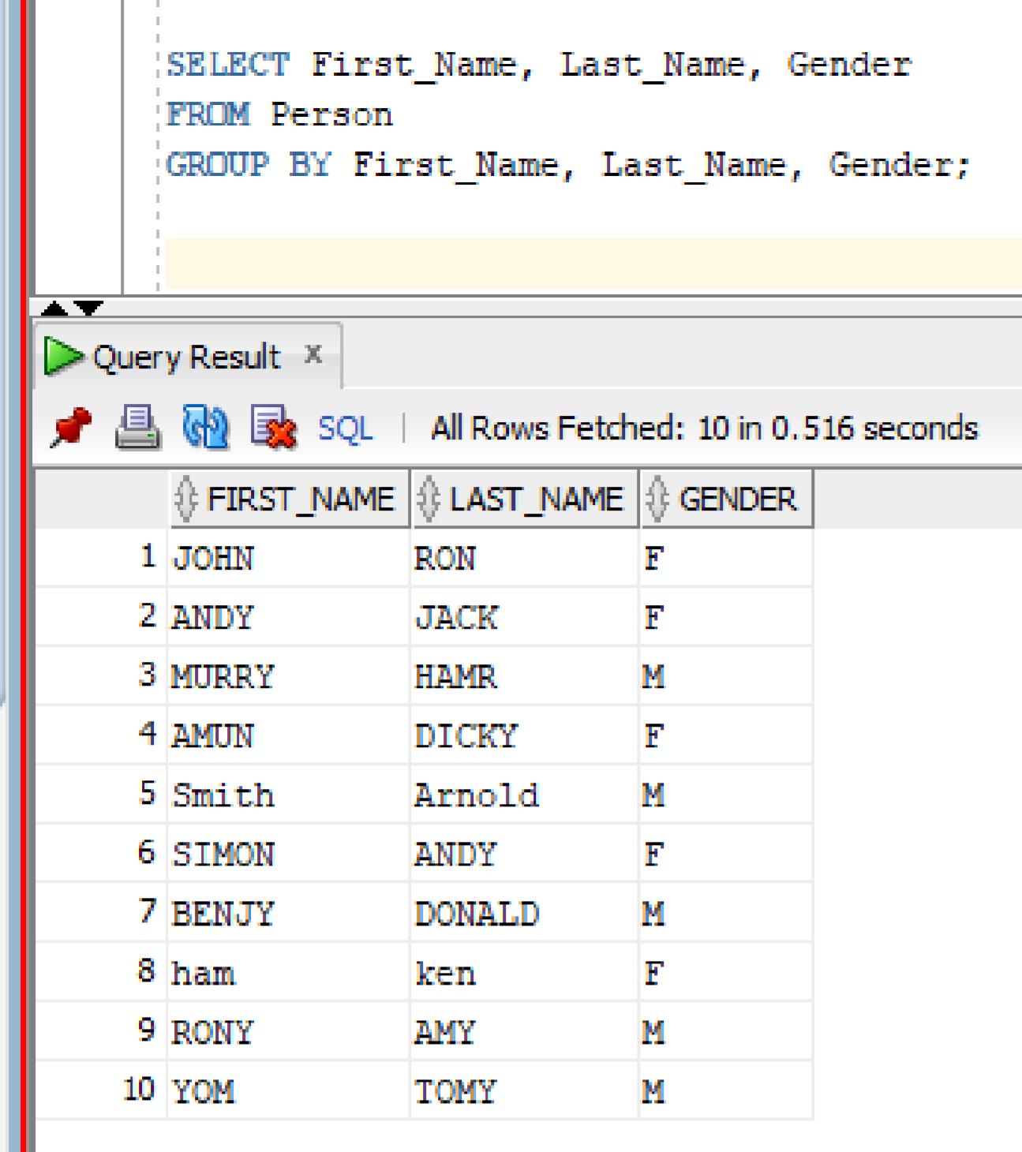

Displaying record from multiple tables (Including associate table)

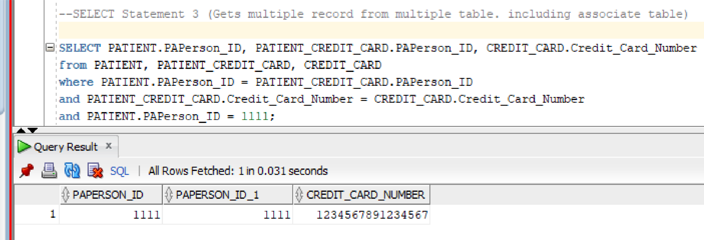

***Testing with UPDATE statements:***

Before UPDATE the INSURANCE_COMPANY Table (Targeted Primary Key “2211”)

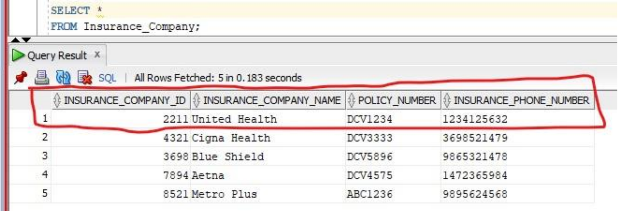

UPDATE query is used to UPDATE the INSURANCE_COMPANY table

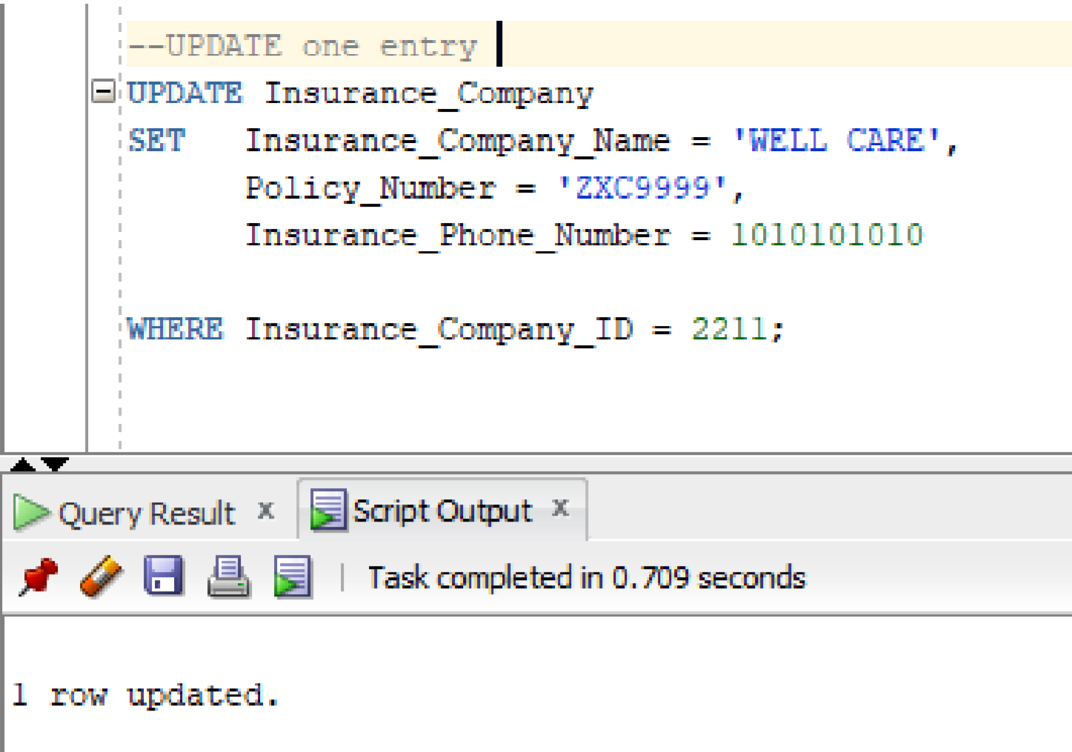

After UPDATE the INSURANCE_COMPANY Table (Targeted Primary key “2211”)

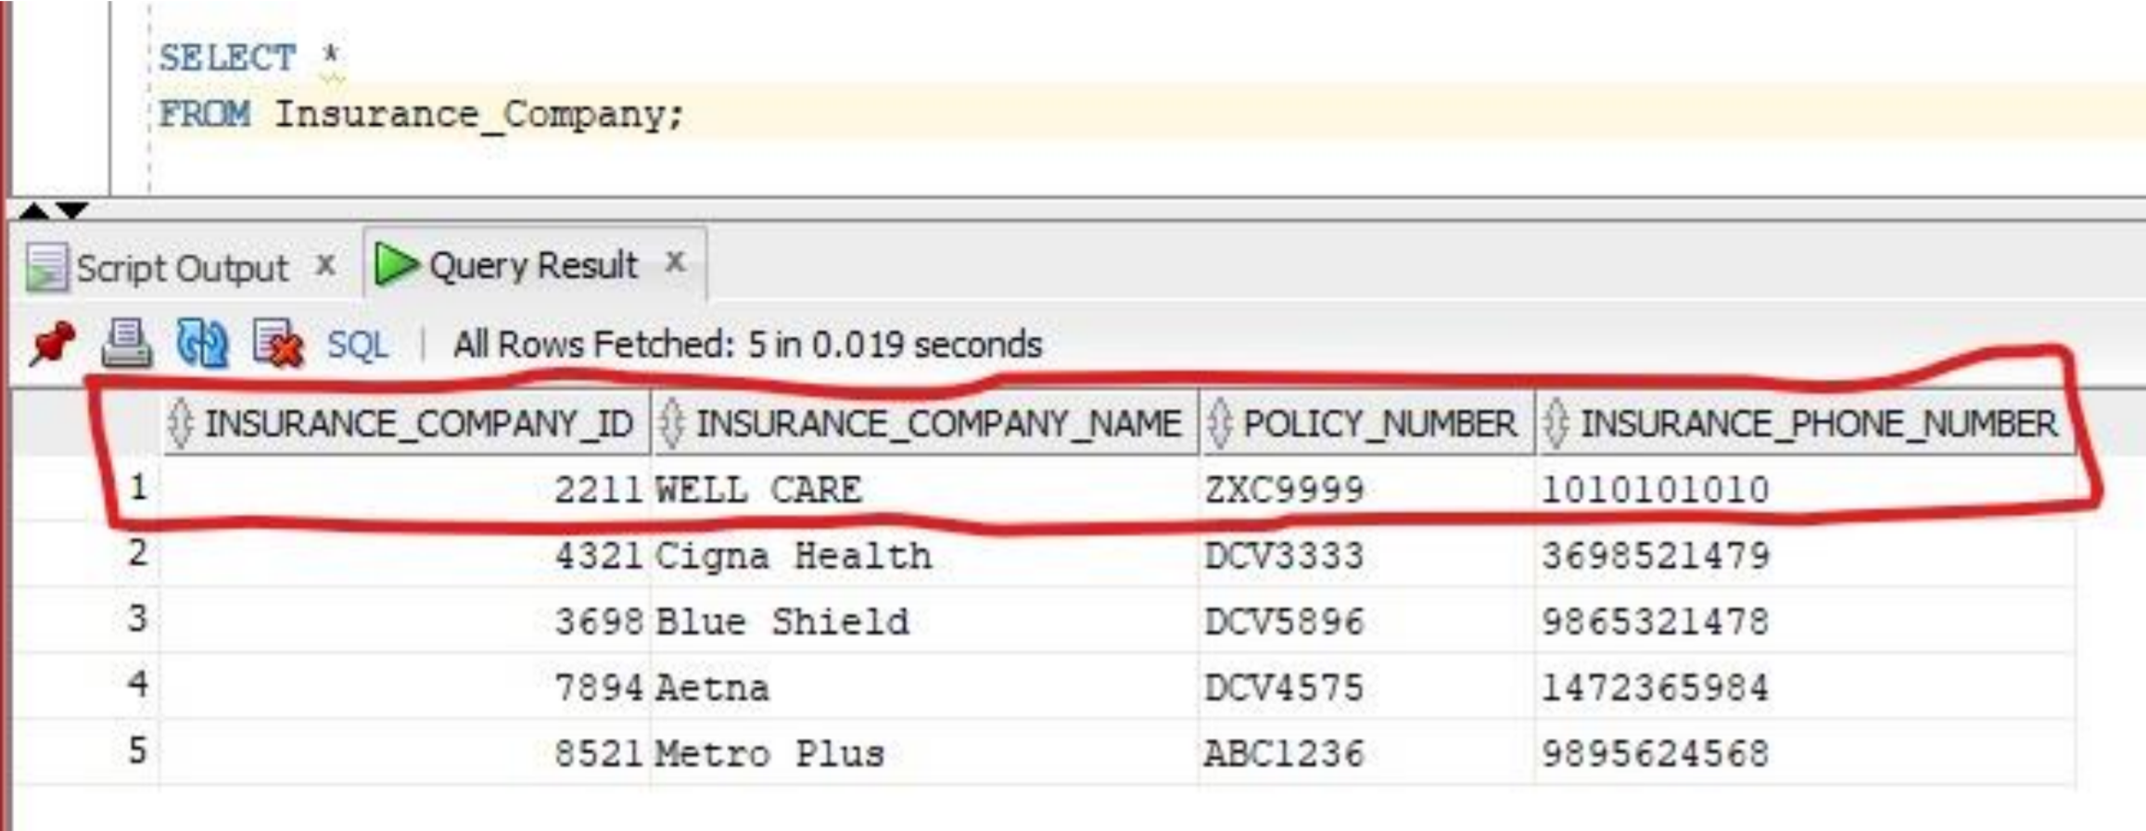

Note: Since selected table group doesn’t have Associate entity table that contains additional columns beside Primary key (Composite key), so UPDATE test for associate entity can’t be done because primary keys can’t be modify.

***Testing with DELETE statements:***

Before DELETE the Targeted Primary Key “9” in INTEREST Table

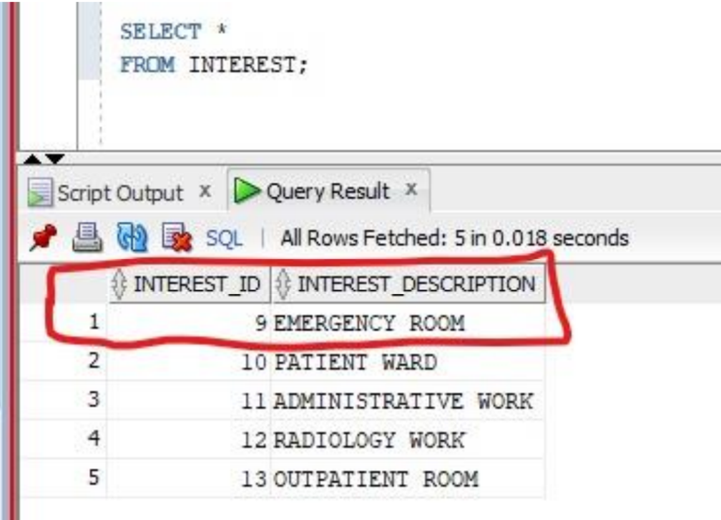

DELETE statement to DELETE the targeted record

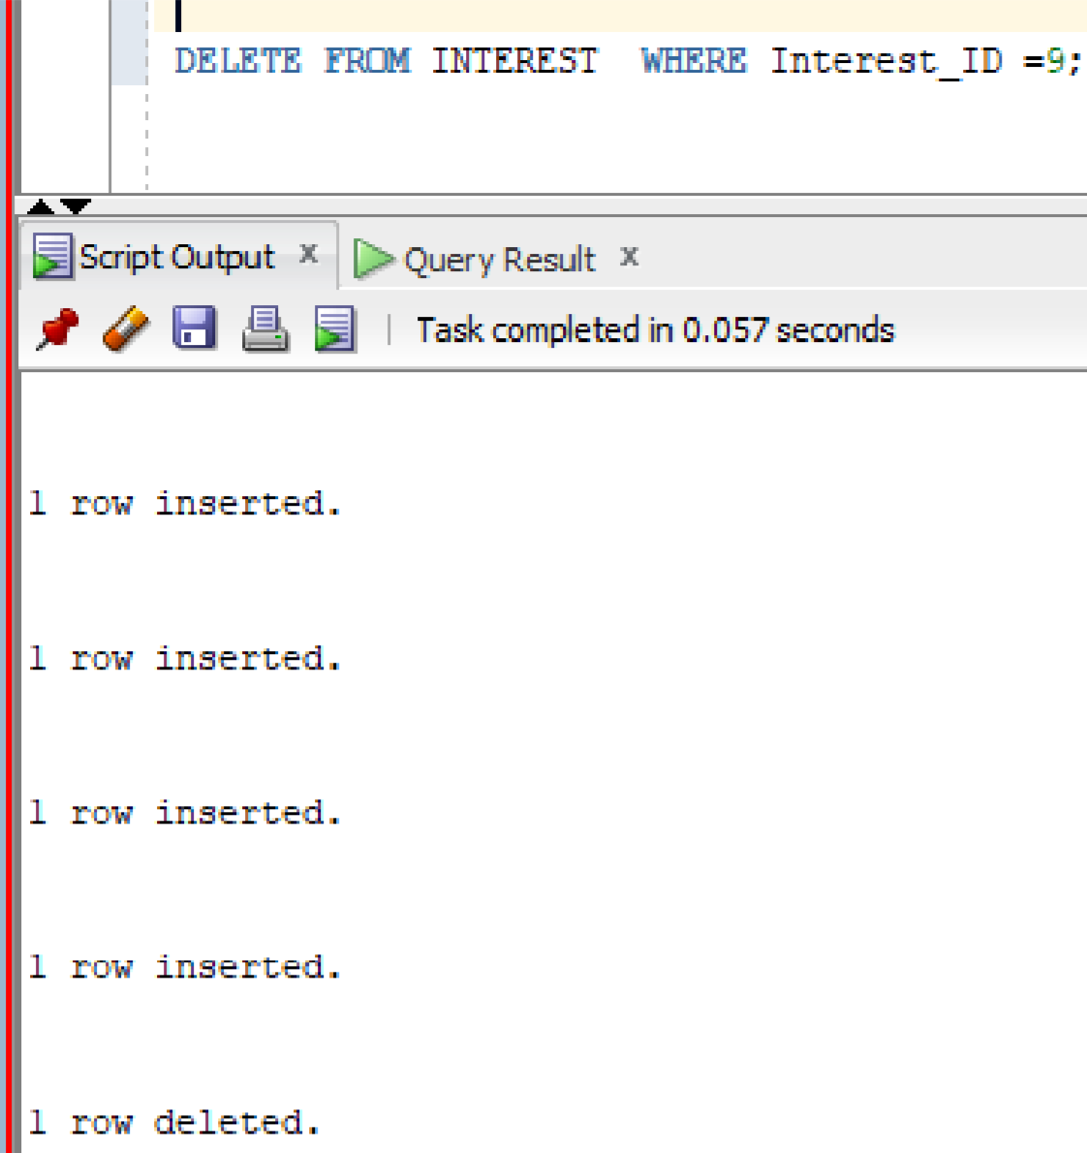

After DELETE the Targeted Primary Key “9” in INTEREST Table (Targeted record deleted)

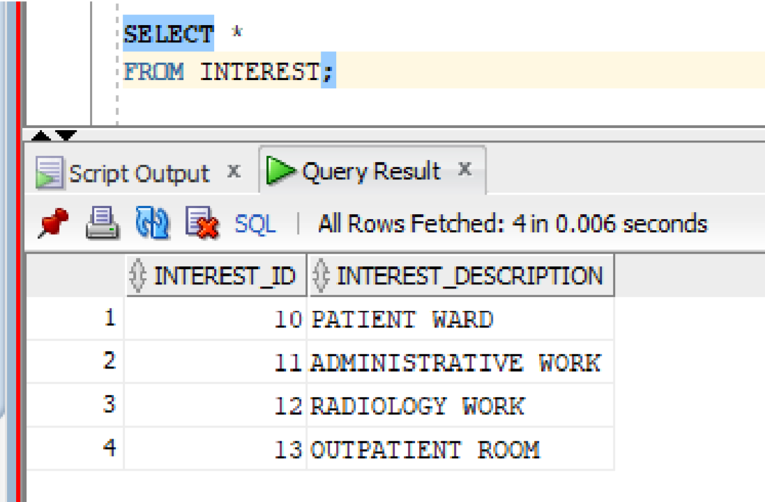

Before DELETE the Targeted Primary key “1111” in PATIENT Table

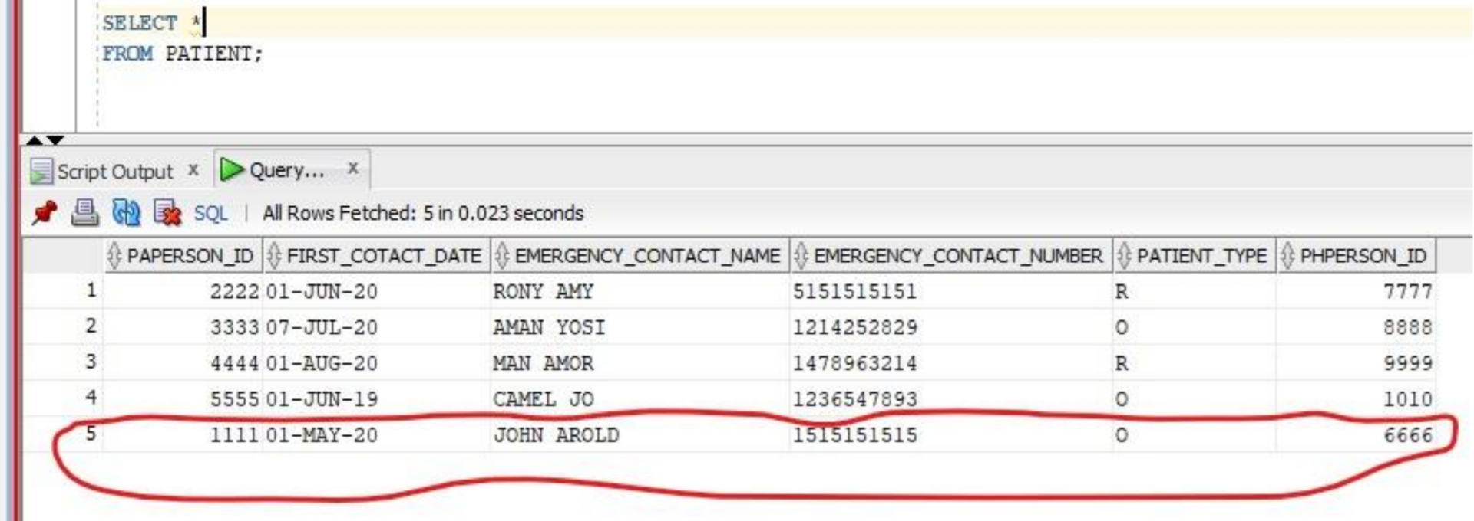

Before DELETE the Targeted Primary key “1234567891234567” in PATIENT_CREDIT_CARD table

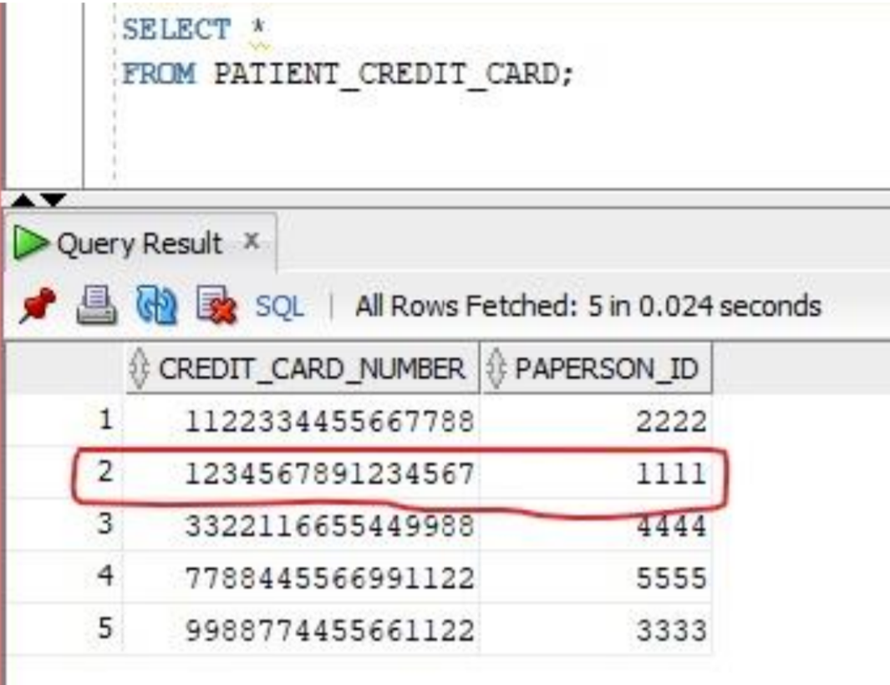

Before DELETE the Targeted Primary key “1234567891234567” in PATIENT_INSURANCE_COVERAGE table

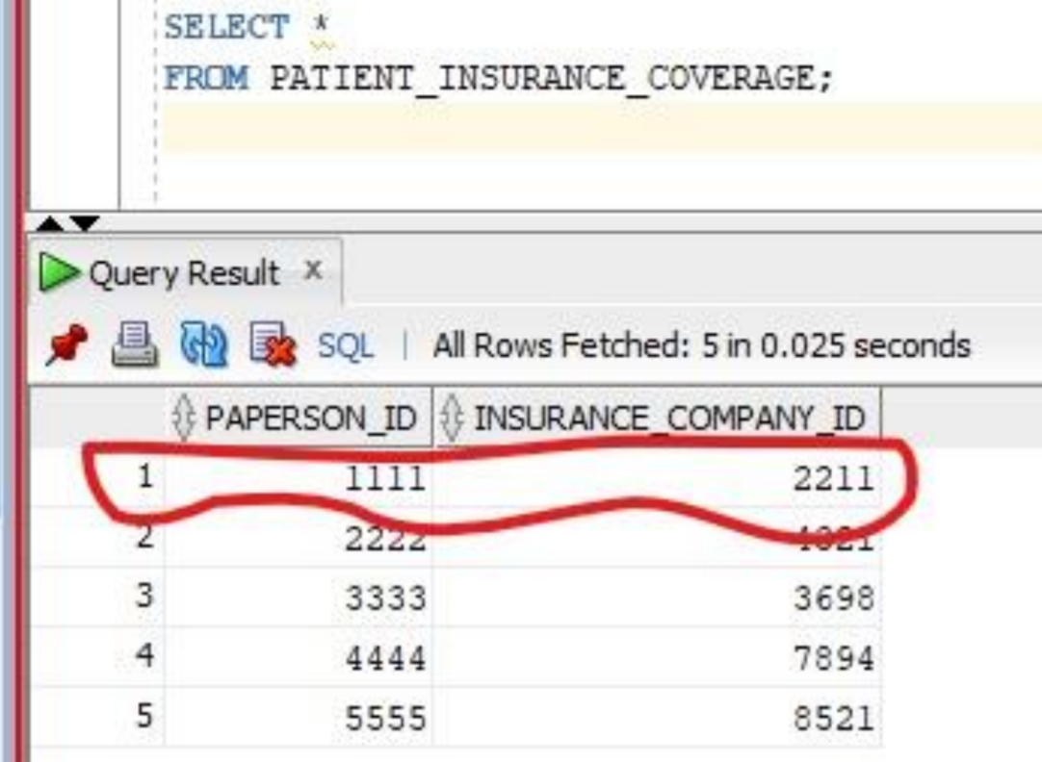

Before DELETE a record from PATIENT table we have to change its associate table (PATIENT_CREDIT_CARD and PATIENT_INSURANCE_COVERAGE) Constraints NOT ACTION to CASCADE. Which will allow to delete a record from both tables at the same time in one script.

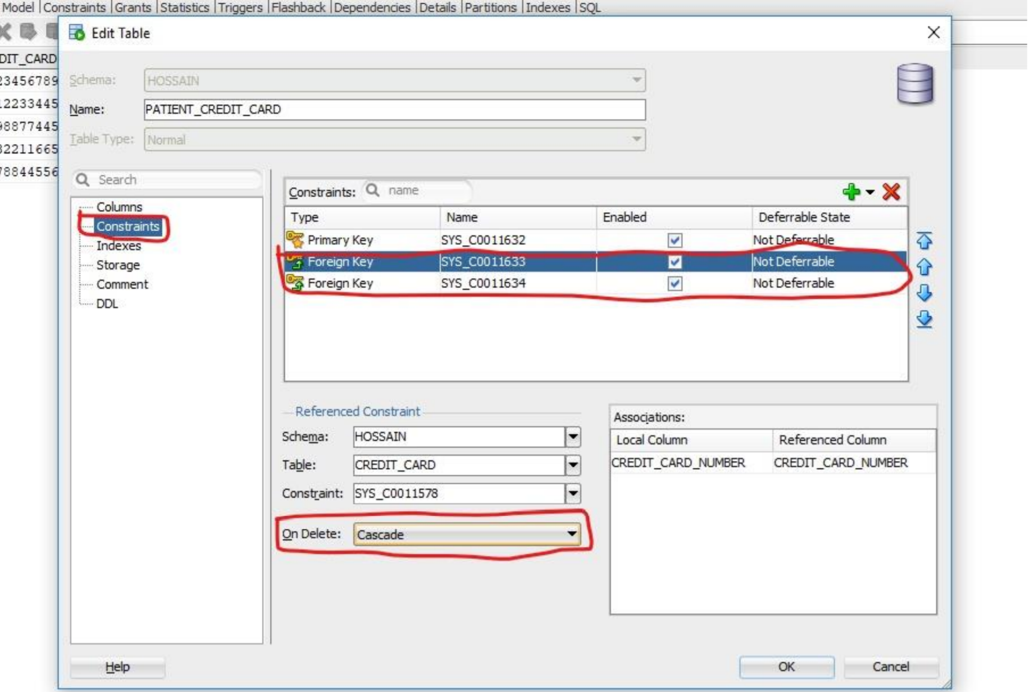

After the CASCADE our DELETE statement (Which will delete a record from PATIENT, PATIENT_CREDIT_CARD, PATIENT_INSURANCE_COVERAGE) Targeted Primary key “1111”

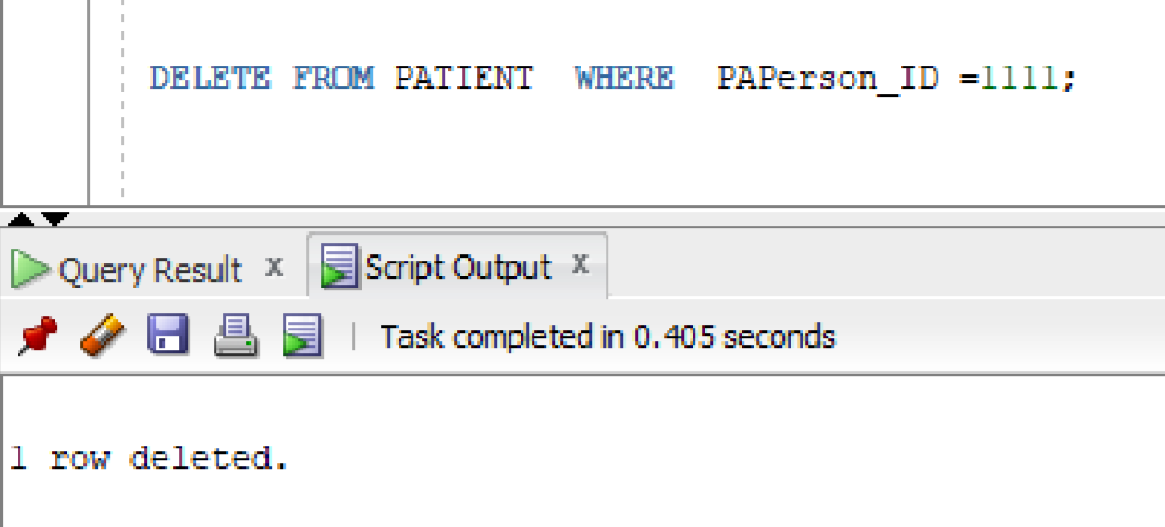

Targeted data deleted from the PATIENT table

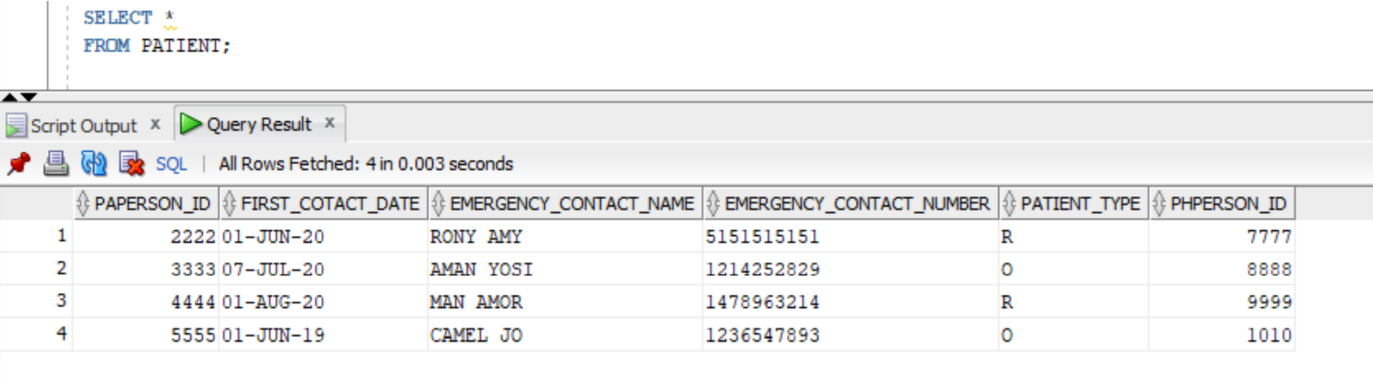

Targeted data deleted from the PATIENT table

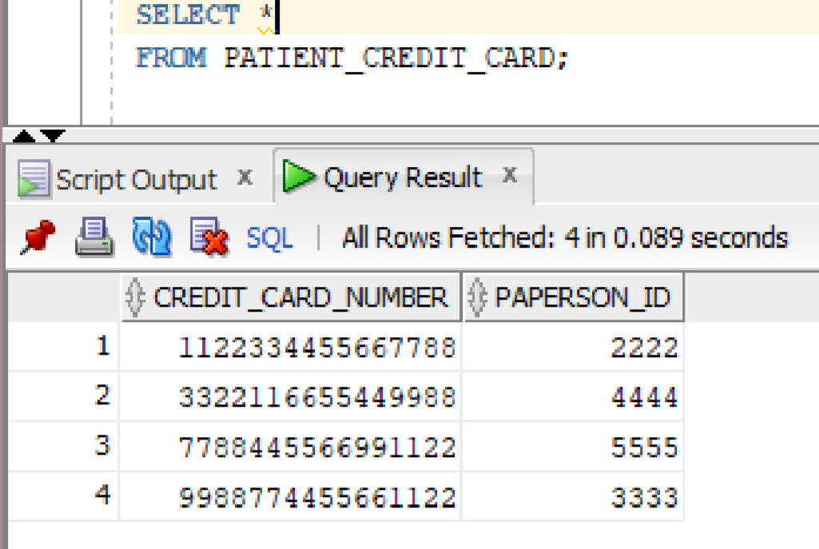

Targeted data deleted from the PATIENT table

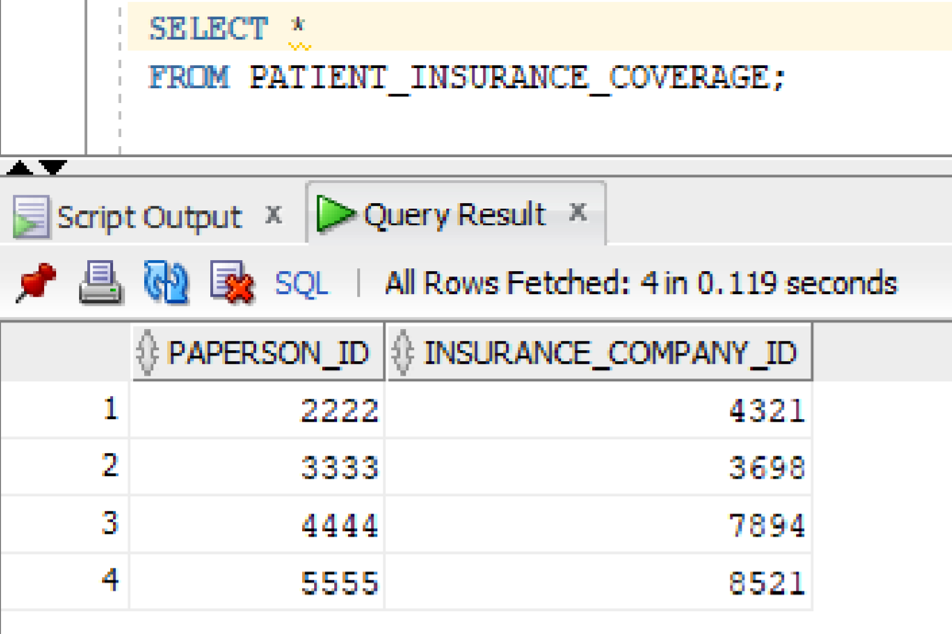

**User Interface**

Below is the user interface for StaySafeMedical.com management system:

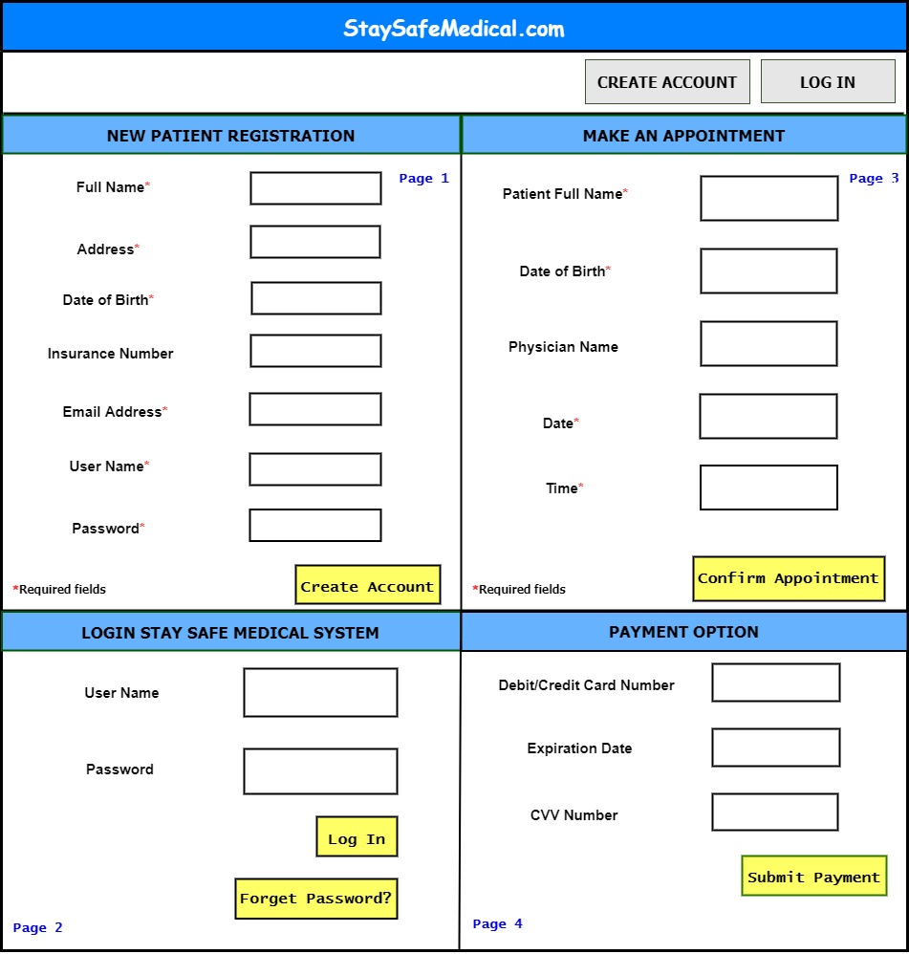

**Conclusion**

StaySafeMedical.com is a convenient and user-friendly Application for the Hospital management system. It will automate the managing of patients and hospital personnel activities in the fastest and easiest way. It will store the data and track all the employees from major cities. To do this job all the project management methodology like planning, analyzing, designing is applied and documented properly.